**i-Log: RFID Log Monitoring System with Thermal Scanner**

A Capstone Project

Presented to the Faculty of

College of Computer Studies

**MINDORO STATE UNIVERSITY**

Calapan City Campus

Masipit, Calapan City, Oriental Mindoro

In Partial Fulfillment of the Requirements for the Degree of

**BACHELOR OF SCIENCE IN INFORMATION TECHNOLOGY**

Meneses, Kiel

Zuniga, Jim Lester V.

February 2022

**APPROVAL PAGE**

This study titled**”i-log: RFID Log Monitoring with Thermal Scannner”** prepared and submitted by Kiel Meneses and Jim Lester Zuniga has been successfully presented and recommended for approval by the Advisory Committee in partial fulfillment of the requirements for the degree, **BACHELOR OF SCIENCE IN INFORMATION TECHNOLOGY.**

**ADDVISORY COMMITTEE**

**SARAH JANE MENDOZA-FESTIJO, MSIT JESUS M. BAUTISTA, MSIT**

Chairperson Adviser

Date Date

**REGINE PONCE-MACHETE, MIT ELMER H.FESTIJO, MSIT**

|  |
| --- |
| Technical Critic I.T Expert  Date Date |

Outside Expert English Critic

Date Date

Director of Research

Date

Accepted and approved in partial fulfillment of the requirements of the degree of Bachelor of Science in Information Technology

**JOHN EDGAR S. ANTHONY, MSI**

Dean, College of Computer Studies

Date

**ACKNOWLEDGMENT**

The researchers wish to express gratitude to those persons who in one way or another contributed to the accomplishment of this research Particular thanks is given to the following:

To Mr. Marcial M. Acha, Jr., Principal of Inarawan National High School and Mr. Alexes H. Dequito, Head of ICT for allowing the researchers to create them an i-log system and for giving them all the information needed to finish the study.

To Engr. Jesus M. Bautista, for sharing his best knowledge, skills, time and effort to check the enhancement of the system and documentation that helped to complete this study.

To Mrs. Regine A. Ponce-Machete, Capstone Instructor of the BSIT Department, for the encouragement and valuable suggestions she has given since the very start of this undertaking.

To their friends and classmates, for the encouragements they had given to finish the study.

To their parents, for their support, either morally, financially and understanding to finish the study and to comply will all their requirements.

And above all, to the great almighty, the author, of knowledge and wisdom, for his countless love, begins and guidance that have been gave to them.

**K.M**

**J.L.V.Z**

**DEDICATION**

This study is wholeheartedly dedicated

toour beloved parents, who have been our source of inspiration and strength when we once thought of giving up,

to our classmates and friends, who shared their words of advice and encouragement,

to our beloved Alma Mater, Mindoro State University, and most of all to the Almighty God, who has given us knowledge and good health while doing this project.

Thank you for your guidance,

strength, power of mind, protection, skills and

healthy life that you have given us.

We offer all of these to you.

**K.M**

**J.L.V.Z**

**ABSTRACT**

Keeping a manual log and obtaining the body temperature of students, teachers, and school staff is causing concern in most schools and universities. The manual logging method on paper takes a long time and results in downtime. An efficient Log monitoring system needs to be implemented at such places. A Radio Frequency Identification (RFID)-based log monitoring system provides a solution that addresses issues such as logging in, Thermal Scanner for quickly obtaining their body temperature, automatic alcohol dispenser for quick and easy sanitizing, and SMS for notifying the users' parents/spouse. This paper describes the design of an RFID-based log monitoring system with a thermal scanner to uniquely identify students, teachers, and school staff based on their RFID cards.

Compared to the traditional way, this makes recording the log effortless, faster, and more secure. This system is intended for usage in various settings, including educational institutions, corporate offices, government offices, and so on. The proposed system consists of both hardware and software components based on IoT technology. The Device Users and IT Experts evaluated the system-device as "Strongly Agree," with an overall mean of (M = 4.81). This means that the device functions correctly and serves its purposes. Therefore, it can be concluded that RFID made it easy for the users to log in and obtain their body temperature. Additionally, the usage of an automatic alcohol dispenser simplifies sanitizing for users.

***Keywords: Arduino, RFID, SMS Notifications, System, Thermal scanner***

**Table of Contents**

TITLE PAGE APPROVAL ii

SHEET ACKNOWLEDGEMENT iii

DEDICATION v

ABSTRACT vi

TABLE OF CONTENTS viii

LIST OF FIGURES xi

LIST OF TABLES xii

LIST OF APPENDICES xiii

**CHAPTER**

1. **INTRODUCTION**

Project Context 1

Objectives of the Study 2

Scope and Limitation of the Study 3

Significance of the Study 4

Conceptual Framework 5

Definition of Terms 6

1. **REVIEW OF RELATED LITERATURE/ SYSTEM**

Local Literature/System 8

Foreign Literature/System 17

Synthesis 33

1. **METHODOLOGY**

Development Method 35

Gantt chart 37

Requirements Specifications 37

Functional Requirements 38

User Interface 38

Hardware Interface 38

Software Interface 42

Security Requirements 44

Technical Background 44

Hardware Specifications 44

Software Specifications 45

System Analysis and Design 45

System Overview 46

System Architecture 47

Use Case Diagram 48

Activity Diagram 50

Data Flow Diagram (DFD) 50

Context Diagram 51

Diagram 0 51

Database Schema 53

Schematic Diagram 54

Sketch Diagram 54

Testing and Evaluation 55

Evaluation Form 55

Participants of the Study 58

Data Gathering Instrument 59

Implementation Plan 60

1. **RESULTS AND DISCUSSION**

Presentation of System Output 61

Evaluation of the System Implementation 68

Results

1. **SUMMARY, CONCLUSION AND RECOMMENDATION**

Summary 80

Conclusions 83

Recommendation 84

**BIBLIOGRAPHY**  86

**List of Figures**

**Figure** **Figure Title** **Page**

1 Conceptual Framework 6

2 Incremental Prototyping 35

3 Gantt chart 37

4 RFID 39

5 MLX90614 39

6 Monitor 40

7 Ultrasonic Sensor 40

8 IR Sensor 41

9 ESP8266 41

10 Water Pump 42

11 Arduino Software 43

12 Sublime Text Software 43

13 Context Diagram of the Current system 46

14 Context Diagram of the proposed system 46

15 System Architecture 47

16 Use case of the developed device 48

17 Use Case of the admin 48

18 Use case of the User 49

19 Use case of the Parents 49

20 Activity Diagram 50

21 Context Diagram 51

22 Diagram 0 of Admin 52

23 Diagram 0 of User 52

24 Database Schema 53

25 Schematic Diagram 54

26 Sketch Diagram 54

27 RFID Scanner 61

28 Thermal Scanner 62

29 Automatic Alcohol Dispenser 63

30 The Monitor 63

31 Login Form 63

32 Forgot Password 64

33 Admin Dashboard Form 64

34 Users Form 65

35 Manage Users Form 65

36 Users Daily Log Form (RFID) 66

37 Users Daily Log Form (Manual) 66

38 Export Data Form 67

39 Department Form 67

40 Account Form 68

**List of Tables**

**Table** **Table Title** **Page**

1 Respondents of the Study 59

2 Five Point Survey Scale 60

3 Implementation Activity 60

4 Level of Functionality of the 69

User and IT Expert

5 Level of Reliability of the 70

User and IT Expert

6 Level of Efficiency of the 71

User and IT Expert

7 Level of Usability of the 73

User and IT Expert

8 Level of Security of the 74

User and IT Expert

9 Level of Functionality of the 75

User and IT Expert

10 Level of Maintainability of the 76

User and IT Expert

11 Level of Portability of the 77

User and IT Expert

12 Properties of Evaluation as a Whole 78

**List of Appendices**

**Appendix Title Page**

Project Team Assignment Form 90

Capstone Project Topic Proposal Form 91

Project Cost 97

Notice of Title Acceptance 98

Endorsement for Final Defense 99

Certificate of Editing and Originality Check 100

Program Listing 101

Data Elements / Dictionary 102

Capstone Evaluation Form 111

Picture during Development 114

Pictures during Final Defense 115

Research/Capstone Project Waiver 116

Certificate of Oral Research Presentation 117

Curriculum Vitae 118

ACM/IEEE Format 122

CD/User’s Manual 129

Code 133

**CHAPTER I**

**Introduction**

**Project Context**

People worldwide have been affected by new technology in significant ways. It has been happening since the beginning of human history. Technological development has various effects on various generations and makes life even simpler than it was previously. Multiple types of presences may be used, ranging from manual to automated using electronic equipment. If the control device logging is recorded using electronic equipment, it becomes simpler, faster, and more reliable.

This study will develop an attendance monitoring system using RFID technology, the Internet of Things (IoT), and cloud technology, resulting in a presence system that can run and be tracked in real-time. The RFID system works the same way as a barcode or magnetic stripe on the back of a credit card: it creates a unique identifier for the item. And the RFID system must be scanned to retrieve the identifying information, much as a barcode or magnetic stripe must be scanned to get the information. (Technovelgy.com)

This study aims to develop a logging system with a thermal scanner that can easily monitor the school's log. Nowadays, long queuing is the main problem when entering any establishment. This encourages the researchers to develop a logging system with a thermal scanner to get their information immediately in a single tap using RFID. The system device can get daily log and body temperature and also can notify the parents via SMS.

**Objectives of the Study**

The main objective of this study is to develop an i-Log: RFID Log Monitoring System with Thermal Scanner.

Specifically, the project will be created to:

1. Integrate the use of RFID card in logging of students, teachers, school employees and visitors and to obtain body temperature, as well as send text messages to their parents/spouse.
2. Design a device that has an automatic alcohol dispenser.
3. Make an automated system to easily find the records of users at any given time with generated reports.
4. Evaluate the device using ISO 25010criteria in terms of:
5. Functional Suitability
6. Reliability
7. Performance Efficiency
8. Usability
9. Security
10. Compatibility
11. Maintainability and
12. Portability
13. Develop an implementation plan for the developed system-device.

**Scope and Delimitation of the study**

The focus of this study is to develop a device that will provide a log-in system and store information of students, teachers, school employees, and visitors who will enter and exit the school premises using RFID. An added feature is a thermal scanner that will notify the parents/guardian and spouse of the student/teacher for their body temperature via SMS. The design and platform of the project is a web-based system that manages the user’s registration and provides the functionality of recording the individual records. The system allows the administrator to export the user log-in at any date, and also it will alarm if the device has detected a high body temperature.

The delimitations of the proposed system device will be the system is only available for authorized users; only the administrator can add, edit, delete as well as update the information; students, teachers, school employees, and visitors enter the school bringing the RFID card of their co-students, co-teachers, co-school employees and co-visitor.

**Significance of the Study**

This study will benefit following groups in different ways from the study and the device as well:

**Administration.** This study will help Inarawan National High School to get knowledge about this research. The outcome of this study may help them open some new and advance technology that may help their school to improve more when it comes to information technology.

**Current Researchers.** The project of this device is to help the individual researchers to think critically and gather their own ideas to make this project whole. This might also helped them contribute to this institution.

**Future Researchers.** This study may serve as their guide and a tool for their future researchers. It will also give them an idea about modern technology and help them improve their skills. It will be an additional knowledge and learning that will help the current researcher to elaborate the current study.

**Parents:** They can easily keep track of their children by sending SMS messages from our system.

**School Employees:** They can easily track their body temperature and record their names by tapping their RFID tags. Furthermore, this device can provide reliable tracking records.

**Students:** They can track their body temperature and conveniently log their names by tapping their RFID. Furthermore, this device can provide reliable tracking records.

**Teachers:** They can easily track their body temperature and record their names by tapping their RFID tags. Furthermore, this device can provide reliable tracking records.

**Visitors:** They can easily track their body temperature and record their names by tapping their RFID tags. Furthermore, this device can provide reliable tracking records.

**Conceptual Framework**

***Figure 1*** shows the conceptual framework. It displays the input, process and the output of i-log. The input includes the offered features of the system-device and there are process needed to be done such as requirement gathering, interview, planning, analysis, design, implementation, testing and maintenance. As the result, the system device 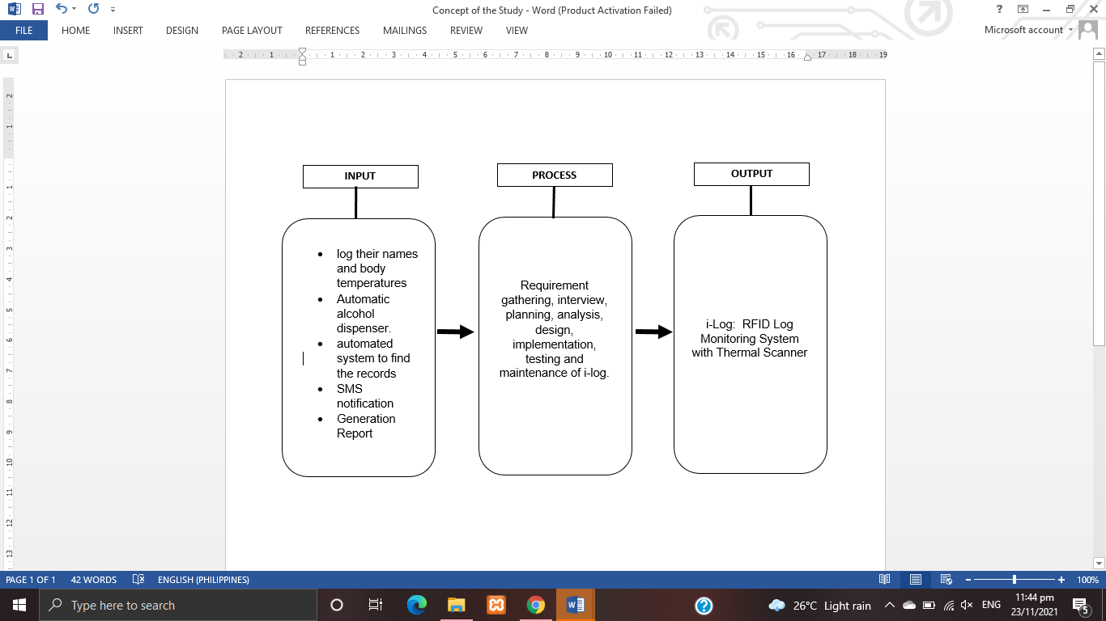will form and perform its purpose.

**Figure 1. Conceptual Framework**

**Definition of Terms**

The following terms are the defined operationally.

**Arduino -** An open-source electronics platform or board, as well as the software needed to program it, is referred to as Arduino. Arduino is a platform for artists, designers, enthusiasts, and anybody interested in developing interactive objects or settings to make electronics more accessible.

**RFID -** (Radio Frequency Identification) is a technique that employs radio waves to identify tagged objects passively. From tracking things in a supply chain to keeping track of things checked out of a library, it's utilized in a variety of commercial and industrial applications.

**SMS notification -** When an event occurs, text messages called SMS notifications are issued. In this case, an event can relate to anything from a fun app update to a life-threatening weather alarm. SMS stands for "Short Message Service," and it is used to send notifications in the same way that any other text message is.

**Thermal Scanner -** A thermal scanner can read an individual's temperature and determine whether or not he has a high body temperature.

**CHAPTER II**

**REVIEW OF RELATED LITERATURE AND STUDY**

The review of related literature and studies is presented in this chapter. It shows the study's similarities, differences, and synthesis in order to compare the various studies and publications that help researchers in broadening their knowledge and achieving their objectives.

**Related Literature**

The following are the literatures that the researchers looked into in order to get information and ideas for developing the proposed system.

**Local Studies and Literature**

**Radio frequency identification (RFID) technology**

According to Gabatbat, D. M et al. (2021), one of the most effective ways to track students' in and out is to use RFID. It will assist both the school and the parents by allowing them to monitor and maintain track of the student's school activities with a single touch. It can be used with the employee module. By tapping the RFID, it will tell their time in and out. This will automatically track their attendance and make calculating their earnings based on the type of job they do, whether full-time or part-time, much easier. If they work full-time, their pay is calculated per day; if they work part-time, their pay is calculated per hour. Students who wish to attend Saint John Academy of Visual and Performing Arts must first enroll and complete a registration form. Employees who do not have RFID must also register, and administrators will provide them with one. They will also be held responsible if a student or employee has an account problem. Admins can also keep track of their actual time spent in and out of the office.

Ibarra, J. B. et. Al (2019) says that the study is looking into developing a system that can track how much energy boarders use compared to how much they actually use. Microcontroller, power analyzer, RFID technology, Wi-Fi server, and relays are all used in this prototype. It calculates each boarder's energy consumption to provide a fair division of electric bills. RFID technology is used to determine who uses the socket and the energy consumption is logged in the Graphical User Interface (GUI). The system's graphical user interface (GUI) allows for real-time monitoring of each appliance's energy consumption as well as the estimated cost of each tenant's bill. The t-test findings reveal that there is no significant variation in current values based on the user's usage.

Go, D. A., Deiparine, C. J., Cuizon, J., & Canonigo, B. (2018) says that to detect absenteeism among kids and notify the appropriate party in real time, deploy mobile and cloud-based notification technologies. Radio-frequency identification (RFID) scanners at the campus's entrance and exit gates gather attendance logs. Students' identification cards have a chip that communicates data to a reader via radio frequency. To reflect whether or not the student enters the campus, the mobile application uses a web API to pull data from the database. The presence of students in their classes is further verified by the faculty via a user interface. Parents and sponsors can monitor their children's presence on campus and in their classrooms in real time. The system uses cloud-based notification systems called Google Cloud Messaging for Android to handle new information in a timely manner (GCM). Missed courses, violations, and class suspensions are all immediately communicated to parents.

**Log Monitoring**

The aim of the research is to develop a fingerprint and WhatsApp-based student attendance monitoring system. It is tough for parents or guardians to keep track of their children's attendance at school because of their busy schedules. Object-oriented and waterfall development methods were employed in the system approach and development. Requirements, design, and implementation are the three stages of the waterfall approach. According to the findings, the system can send WhatsApp messages about pupils' attendance. The system can assist teachers in monitoring student attendance data and in telling parents or guardians of students about when and where their children come and leave school. Aside from that, it can assist in telling pupils of their presence on that day so that parents or guardians are aware that their child is at school. The technology also sends a summary of student attendance statistics throughout the course of a semester to a parent's or guardian's WhatsApp number. RAHMATYA, M., & WICAKSONO, M. (2021).

According to Reynoso, M. M., & Torres, A. M. (2020) Every organization recognizes the strategic value of attendance tracking. Biometrics, radio-frequency identification, Bluetooth and smart technologies, Internet of Things (IoT), cloud computing, or face recognition technology have replaced paper-based attendance monitoring. Tempus is an automated attendance tracking system that uses facial recognition technology for input, real-time IoT capabilities for processing, and mobile platform portability for output. It has both hardware and software components. Maggay, J. G. (2017).

The study's goal was to create a fully tailored Biometric Attendance Monitoring System (BAMS) for Cagayan State University – Lasam Campus, Philippines (CSU - Lasam) that used a biometric fingerprint scanner to make staff attendance easier to track. The researcher recognized the challenges and issues encountered in the monitoring of attendance, set the study's objectives, planned and created the system, installed and tested the system, and reported the study's findings using the Design Science Research for Information Systems framework. The system was created using a mix of Visual Basic 6.0 as the programming language and MS Access as the Database Management System. As a result, the entire capability of the BAMS allows users to enter data, alter and manipulate data, obtain information, and save data and information. Since all transactions employ a unique fingerprint to validate users, username and password are no longer required. In addition, the BAMS makes a significant contribution to putting employees at ease and improving work values. Similarly, the BAMS is critical for effective governance because it keeps track of employees' daily attendance.

**Thermal Scanner/Body Temperature**

People all across the world are showing signs of terror as a result of the rapid spread of the global pandemic COVID-19. Regardless of the degree of direct contact with the infected, this has an impact on the county's economy, social values, and psychological stress among those affected. The goal of this study is to examine people's panic reactions as well as their perceptions of the worldwide issue. Both quantitative and qualitative data were interactively evaluated and interpreted. The results also demonstrate a significant difference in Avoidance behavior between locations (p=0.028). Furthermore, there is a significant difference (p=0.000) between exposure to COVID-19 and hypochondriasis symptoms. Indifference, Annihilation, Nihilism, Paranoia, Sadness, Fear, Virus Transmission, Shock, Government Blaming, Anxiety, Relating to Past Pandemics, Worry on Self/Family/Others, Information Dissemination, Composure, Compliance, Protection, Cautiousness, Optimism, and Health Consciousness were also conceptualized with the following themes arranged from negative to positive behaviors: ( Nicomedes, C. J., & Avila, R. M. 2020).

**SMS Notification**

Information system (IS) is an information technology (IT) solution that uses advanced technology to support multiple business operations using hardware, software, people, networks, and data. Scholarship management systems are an example of an information system meant to aid any university's scholarship awarding procedure. Instead of constructing a whole software system from scratch, it is critical to consider the reusability of some components while designing such systems. In this paper, a scholarship management system was created by combining a QR-Code tracking system with a short messaging service (SMS) notification transaction interface. The study's findings revealed that the system's functionality, execution, generality, and reusability in its source code received good ratings from two perspective reviewers. (Secugal, K. A. S., Sermeno, J. P., & Mistio, N. E. 2021).

A barangay is the Philippines' smallest government unit and the native Filipino term for a village or hamlet. It is controlled by elected officials, with the Punong Barangay (Barangay Chairperson) at the top and the Sanguniang Barangay (Barangay Councilors) at the bottom. Because of the rapid advancement of modernity and technology, barangay operations must stay up with this new technology in order to deliver better service. Unfortunately, the majority of barangays are currently unprepared to implement this type of innovative technology. One of them is Barangay Labas, which is one of the 18 barangays in the City of Santa Rosa, Province of Laguna, that uses manual document processing and manual information delivery to its citizens. The SMS Notification System for Barangay Labas, City of Santa Rosa, Laguna is a system that will assist the barangay in processing document requests and sending the most up-to-date information to its citizens. Through the use of Short Message Services Technology, this system can handle a document request in the quickest and most convenient manner possible, as well as convey information to its people in the quickest and most convenient manner possible (SMS) (Batitis, C. A., Alcaide, E. S., Arguillon, M. V., Roldan, J. M., & Agustin, L. F. 2019)

According to Overspeeding Obiso, J. J., Aparre, L., Balboa, L. H., & Ybanez, E. (2019). In the Philippines, motorcycles are the leading cause of motorcycle-related accidents. Motorcycle drivers are frequently unaware that they have surpassed the regular speed limit when driving. To overcome this issue, a solution has been created that uses a Hall Effect sensor to detect overspeeding. This technology uses a buzzer to inform the driver when they are speeding. Using the Global Positioning System (GPS) module, the system may also offer location information for the motorcycle. These details can be provided through Short Message Service (SMS) to the dedicated user and stored on a Secure Digital (SD) card. The following experiments were carried out at three different sites inside Cebu, Philippines, to assess the performance of the proposed system: GPS response test, Hall Effect sensor response test, and data recording test. The results of the experiments showed that the constructed system was capable of doing the tasks it was designed to do. It detects over speeding, transmits location details to the devoted user via Short Message Service (SMS) messages, sounds the buzzer when the speed limit is exceeded, and retains the information details on the SD card. As a result, the technology contributes to the literature by serving a dual purpose: detecting over speeding and tracking the location of motorcyclists. Future researchers should integrate an intelligent function such as automatic slowdown when the driving speed exceeds the speed limit in order to improve the system's performance even more. It would be ideal if collision detection and avoidance procedures could be included as well.

**Foreign Studies and Literature**

**Radio frequency identification (RFID) technology**

Sensors and wireless data transmitters could be utilized to improve the functionality of billions of everyday items. The development of upgraded battery-powered sensors and smart devices with on-board radio and computer capacity has become a new research topic for the Internet of Things (IoT). IoT devices enable us to build strong data-driven apps by acquiring extensive environmental information about an object. To run the circuitry and transfer the data, these devices are usually fueled by batteries or direct electricity. Battery-powered devices are expensive and require frequent battery replacements, resulting in higher maintenance expenses and limiting their use. The growing desire for low-cost wireless connectivity opens up a lot of possibilities for using passive sensors to enhance everyday objects. Radio Frequency Identification (RFID) passive sensors are a low-cost option. (Kantareddy, S. N. R., 2020).

In this study, the researcher first analyzed the underlying causes of poor return rates before developing a unique Radio Frequency Identification-based return route to boost recycling rates. A dual-recovery-channel hybrid manufacturing-remanufacturing production model is developed, in which used items of varying quality are obtained through both the old market-driven recovery channel and the new RFID-based channel. A mathematical model is created that takes into account the cost of implementation as well as the architecture of the proposed RFID-based recovery channel. The results reveal that a hybrid collection strategy with an 85 percent share of channel-1 and a 15 percent share of channel-2 is the best choice for recovery channels. Furthermore, when demand rises, so does the collection via the RFID-based pathway provided. In the proposed RFID-based system, reader sensing power is judged to be more important than reader cost (Ullah, M., & Sarkar, B. ,2020).

According to Kantareddy et.al,(2019) use a 10.1 percent efficient perovskite PV module with an active area of 1.06 cm 2 under 1 sun light and an AM 1.5G spectrum to power a commercial off-the-shelf RFID IC that requires 10 - 45 W of electricity. An on-board energy harvester provides extra energy to expand the sensor's range and to do high-volume sensor measurements. Perovskite solar cells can meet the energy requirements for future fully power-autonomous low-power RF backscatter applications, according to our prototype analysis. Finally, the researcher take a look at some of the applications that anticipate will benefit from the synergies created by combining perovskite photovoltaics and RFID.

Printed graphene is a low-cost and environmentally friendly alternative to etching aluminum or copper for making radio frequency identification tags. At UHF, an alternative to radiating far held is to use inductive near held as the coupling mechanism between the reader and the tag. Although the read range of a close-held tag is limited, the tag is extremely basic and tiny. The attachment of the microchip is an important step in the tag production process that influences the tag's final cost. (Jaakkola, K., Sandberg, H., Lahti, M., & Ermolov, V., 2019).

Because RFID is widely utilized in large-scale tag-based applications, robust anti-collision algorithms are essential for RFID's energy and time efficiency. MAC algorithms in use today are primarily concerned with enhancing system throughput or reducing overall identification time. The energy consumption issue is becoming increasingly important as embedded systems and mobile apps evolve, and it should be incorporated into the new design. . The first part of this paper examines and analyzes the most modern anti-collision algorithms. They discuss a novel anti-collision algorithm design and illustrate its usefulness in achieving energy efficiency for the RFID system using the EPCglobal C1 Gen2 UHF standard, based on our prior work. (Su, J., Sheng, Z., Leung, V. C., & Chen, Y. ,2019).

**Log Monitoring**

According to Lazzaretti et.al, (2020) One of the most important concerns confronting many countries today is energy. The need for energy in industrial expansion has reached previously unheard-of heights. Many solutions are presented, including an Energy monitoring and prediction system, which is an effective approach for monitoring the gadgets present inside a home or industry and alerting users to abnormal behavior. It is researched the adoption of an IoT-based system for competent energy management in industries and at home. Other related works do not present the integration of a fault detection and classification approach with an embedded PV plant monitoring system, allowing for the online identification and classification of different PV faults, as well as real-time and historical monitoring of the plant's electrical and environmental parameters, which is an original contribution of this work. Cloud computing is a fast expanding remote computing environment that offers customers on-demand computational resources and services over the Internet. OpenStack is a well-known open source platform that assists in the creation of private clouds for businesses. Log management is essential for identifying and resolving various errors in the cloud network. It's often tough to keep track of and interpret logs. It makes it easy to read for admins. Aside from that, our logic aids in the generation of warning messages prior to the various resource quotas, such as virtual CPUs, Floating IPs, and so on. A tool like that can assist the administrator in increasing or releasing quotas, avoiding the trouble caused to users who create virtual machines. (Agrawal, V., Kotia, D., Moshirian, K., & Kim, M., 2018).

Self-monitoring blood glucose (SMBG) logbooks are useful for modifying insulin regimens and establishing glycemic control in people with type 1 diabetes (T1DM). Inconsistencies in SMBG charting, on the other hand, may limit its utility. The goal of this study was to see how accurate log entries were and how they affected long-term glycemic control. The dependability of SMBG logs among children with T1DM is a major concern at our institution. Children who kept meticulous records of their SMBG levels were more likely to have long-term glycemic control. (Selvan, C., Thukral, A., Dutta, D., Ghosh, S., & Chowdhury, S. ,2017).

Apache Kafka is a scalable publish-subscribe messaging system that is built around a distributed commit log. It started out as LinkedIn's unified event pipelining platform for tasks involving online data integration. During the years that the researcher have been developing and managing Kafka, they have extended its log-structured architecture as a replicated logging backbone for much bigger application scopes in the distributed environment. The researcher will present their design and technical expertise at LinkedIn in replicating Kafka logs for a variety of distributed data-driven systems, including source-of-truth data storage and stream processing, in this abstract. (Wang G. et.al, 2016).

**Thermal Scanner/Body Temperature**

Both endothermic and exothermic species sustain lifespan extension at low temperatures, while the mechanism behind this transition in aging is unknown. Low temperature is thought to slow metabolic rate, preventing the accumulation of cellular damage from reactive oxygen species, but newer data suggests the involvement of specialized cold-sensing biochemical systems. They identified differences in median lifespan change, which ranged from 6% to 100%, as well as differences in maximal and relative lifetime extension and mortality rate. Although TRPA1, a well-known low-temperature sensor, is found in the rotifer genome, pharmacological TRPA1 agonists had no effect on survival, showing that this gene is involved in low-temperature sensing but not chemoreception in rotifers.(Gribble et.al, 2018).

The goal of this study was to compare a range of cooling technologies that occupational workers might utilize, with a focus on their effects on body temperature, perception, and hand dexterity. In the current investigation, swallowing ice or applying ice to the skin had the greatest impact on rectal and skin temperatures, respectively. AI should not be deployed if future workers demand fine physical skill. Future research on the best pre-cooling processes for occupational workers will benefit from these findings. (Maley, M. J. et. al, 2018).

Biodiesel generated from microalgae, according to Kim E et al. (2016), is a promising alternative energy source. Low growth, on the other hand, makes outdoor mass cultivation for biodiesel production difficult in the winter. The Researcher show that Arctic Chlamydomonas sp. can be found in the Arctic. KNM0029C thrives at 4 °C and can reach densities of 1.4 107 cells per milliliter1. Using BODIPY 505/515 staining and fluorescence microscopy, the formation of lipid bodies in the alga was observed. KNM0029C produced 178.6 mg L1 of fatty acid methyl ester (FAME) culture at 4 °C, which was 2.3 times greater than C. CC-125 Reinhardtii. Polyunsaturated fatty acids such as C16:3, C18:2, C18:3, and C20:2 dominated the FAME content analysis. At 4 °C, C18:3 fatty acids made up the largest fraction (20.7%), while polyunsaturated fatty acids (39.6%) outnumbered saturated fatty acids (6.8 percent ). These data point to Chlamydomonas sp. as a possible pathogen. In frigid settings, KNM0029C, a psychrophilic microalga, could be a promising source of biodiesel.

In health monitoring and other biomedical applications, a flexible organic temperature sensor array has a lot of potential. Even if the item has an irregular shape, the actively addressed 16 16 temperature sensor array achieves a yield rate of 100% and provides 2D temperature information of the objects in touch. Electronic device defect prediction, remote sensing of harsh environments, and e-skin applications are all possible with the current device. (Ren et.al, 2016).

**SMS Notification**

Liquefied Petroleum Gas (LPG) is readily available to clients all over the world because it is a clean, portable, and efficient source of energy. Hundreds of millions of people use LPG around the world, and it has over 1000 applications. Cylinders of LPG can leak as a liquid or a gas. LPG may explode or burn if an ignition source and a gas come into contact. LPG can endanger the lives of persons within the house and cause cold burns. . The goal of the project is to create a device that can detect gas, smoke, and flame from an LPG cylinder and send a text message to the owner, ensuring the safety and security of LPG users. The system can also alert the owner by displaying a warning message and sounding a siren. To guarantee that the system's accuracy was 100 percent, the researchers conducted functionality testing with twenty (20) trials. When users use the system at home, it indicates that it is dependable and efficient. (Malbog, M. A. et. al, 2020).

Technology advancements in the disciplines of Science and Technology are forcing all acts and things used in daily life to become inextricably tied to technology. This advancement gives the impression of a transition from an old to a newly constructed system. One emerging breakthrough is microcontroller technology, which can now be used in numerous aspects of the environment. This research will lead to the development of an automatic lamp prototype that can save electricity in a room, reducing the amount of electricity wasted by the State Electricity Company (PLN). This prototype technique combines a human motion detection sensor with a Passive Infrared (PIR) sensor, which is then connected to the Arduino Uno microcontroller, which serves as the sensor's control center. A Light Dependent Resistor (LDR) sensor, commonly known as a light sensor, is used in conjunction with the PIR sensor to determine the light intensity required in the room, allowing controlled lights to be utilized in accordance with the intensity of the room's light. Additionally, there is a GSM Sim 900A that acts as a warning if electricity is utilized outside of the sensor controller. (Leandros et.al, 2020).

According to Hasibuan, M. S., & Idris, I. (2019) A gas is an unbound, formless, and invisible molecule that can convert into a search or solid at particular temperatures and pressures. LPG gas is a necessity for both businesses and households, particularly for cooking. Many fires in Indonesia are caused by LPG gas; a defective gas regulator is a major cause of LPG gas fires. As a result, firefighting requires both prevention and security. As a result of this, and in light of technological improvements, an intelligent Arduino-based gadget capable of solving this obstacle was built. This tool includes MQ-2, SIM800L, and buzzer gas sensors. The system in an embedded device can translate data received from the sensor Mq-2, which detects propane and butane gas, and then provide the actual data in the form of short messages (SMS) to the mobile phone registered in the system. Aside from being able to transmit SMS, the device also makes a buzzing sound.

**Synthesis of the Study**

These various related studies and literature, as well as the use of RFID and various monitoring systems, will provide researchers with additional information to supplement what they already know in developing the proposed system.

The issue that the researcher observed was long queues of students, teachers, employees, and visitors, as well as difficult data retrieval when the administration wanted to track the logs.

However, the study's goal is to create a monitoring system that uses RFID cards and readers, and the related studies will serve as guidance for the researcher on how to create a non-existing system with unique features that will allow administrators to effectively track students, teachers, employees and visitors.

**CHAPTER III**

**METHODOLOGY**

This chapter presents the design, plans, and diagram to easily visualize the flow of the proposed project.

**Research Approach**

To allow the researchers to collect the necessary data, the observational method was used. This is to determine how involved the participants are with the project. The researchers got an in-depth insight of project activities by acting as participants, which might be valuable for project planning, implementation, and evaluation. In this case, the participant observation method was also used during the planning phase to assess the community's needs.

Similarly, during the implementation phase, this method is used to improve the developed project while the researchers monitor it. The evaluation phase, on the other hand, used a similar method to observe and understand how the participants used the device.

The Development Research Approach was also used. The researchers were able to identify the changes that needed to be made in order to create a much improved method of logging.

**Development Method**

i-log: RFID log monitoring system with thermal scanner uses System Development Life Cycle (SDLC), a series of phase in the development process that helps to produce an effective, cost-efficient, and high quality device.

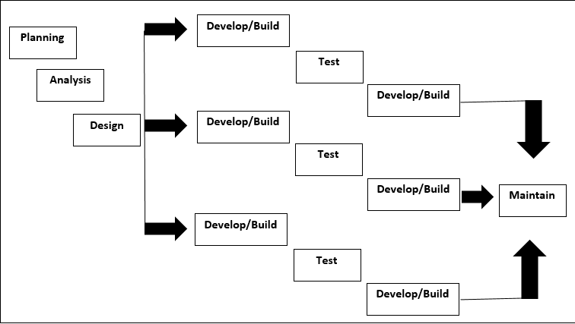 Specifically, this project made use of Incremental Prototyping. This model is the easiest way to understand the flow. Every incremental phase has a view of the process to display the detailed plan on the development process. The phases include planning, analysis, design, implementation, testing, and maintenance.

**Figure 2. Incremental Prototyping**

The research followed the following phase.

* **Planning.** This phase is the process of making plans and considering the activities required to complete the development project. Making plans for what the researchers build and conducting research on the things they'd like to build.
* **Analysis.** During this phase, researchers considered how to create a device that will be of great assistance to the school. The developers consider the issues they encountered upon entering the school. As a result, they discovered that the school need this project.
* **Design.** During this stage, the researchers began to design a device based on the needs of the user.
* **Development and coding.** During this stage, the developers began coding in the Arduino Uno software and the Sublime Text application software. And create a device that allows the user to see how the device functions and works.
* **Testing.** In this case, the researchers tested the device several times to ensure that it worked and that the user would not encounter any potential errors in this project.
* **Maintenance.** During this stage, while the device is being deployed, the developers must maintain their project in order to determine whether the existing problems will be resolved in time. The wirings should also be checked to prevent the device from malfunctioning, and the researchers should keep the device cool to avoid overheating.

**Gantt chart**

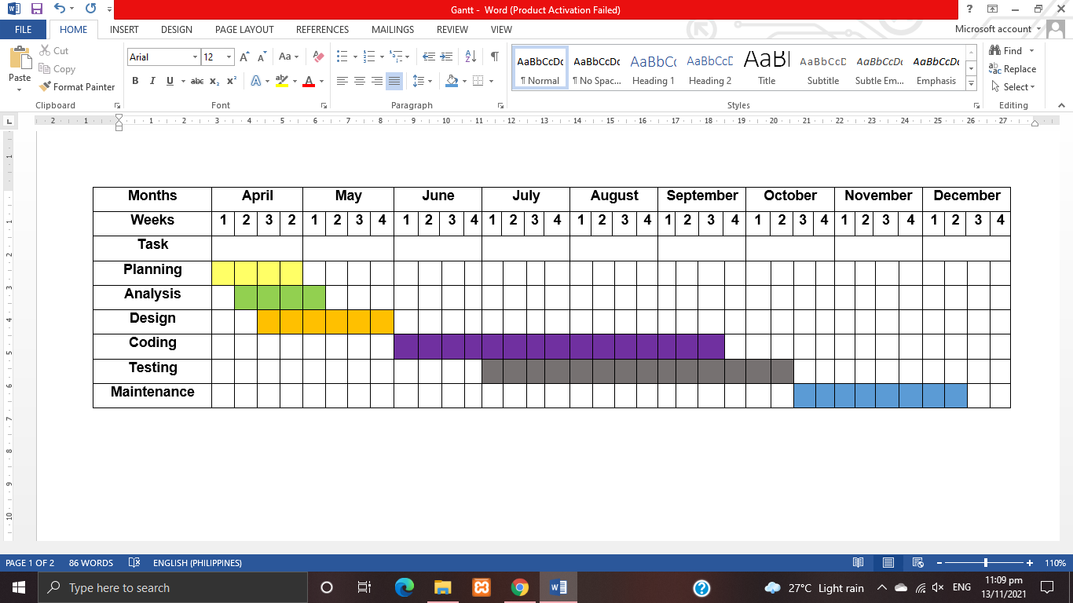***Figure 3*** shows the whole process of the developing the i-log: RFID log monitoring system with thermal scanner.

**Figure 3. Gantt chart**

**Requirement Specification**

The user must meet the device's function to utilize the proposed project fully. The user must be familiar with the materials to be used and have sufficient knowledge of the hardware materials such as Arduino Uno, NodeMCU, RFID, MLX90614, and Ultrasonic Sensor.

**Functional Requirements**

Functional requirements are features that should be included in a system to meet business needs while also being acceptable to system users. Functional requirements describe the system's set of inputs, behavior, and outputs.

To begin the development of the program, the proponents confirmed the need for other important information about the proposed system. At this point, the proponents had gathered essential facts and information about the current system, the function of the proposed system, and a detailed process description of the system components.

**User Interface**

Project i-log makes use of interaction to the users as well as the staff and admin by using RFID sensors and monitor display to see the log informations. The appearance of the system-device was properly prepared using sublime text and sketch up application before making the whole prototype to ensure that the device has pleasing overall look.

**Hardware Interface**

The Hardware Interface section discusses the parts and components of the developing device that will be used to create a proposed project. This also goes over the descriptions of the following components and how they work in this device.

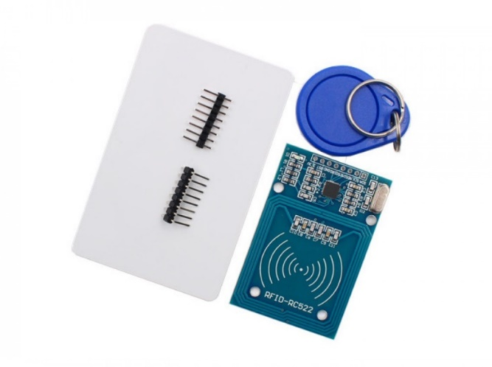***Figure 4***presents the role of the RFID, which automatically detects devices, collects data from RFID tags, analyzes the data, and sends back real-time alerts if necessary.

**Figure 4. RFID**

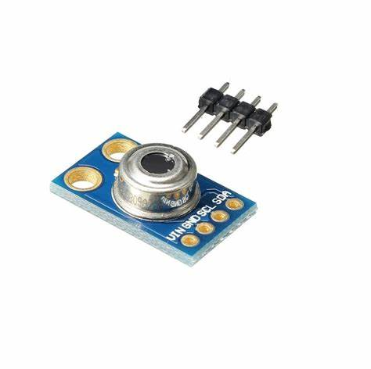***Figure 5*** demonstrates that the use of MLX90614 will obtain accurate body temperature. Our device may use this to identify whether a user's body temperature is normal or high.

**Figure 5.MLX90614**

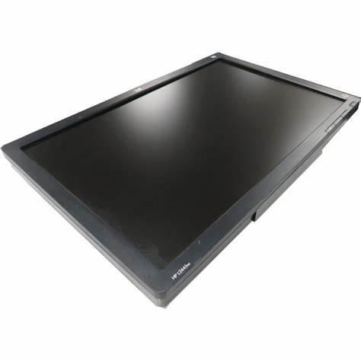***Figure 6*** shows how information is displayed when users tap their RFID and wrist. Their names, pictures, body temperatures, and the time they log are all displayed on the screen.

**Figure 6. Monitor**

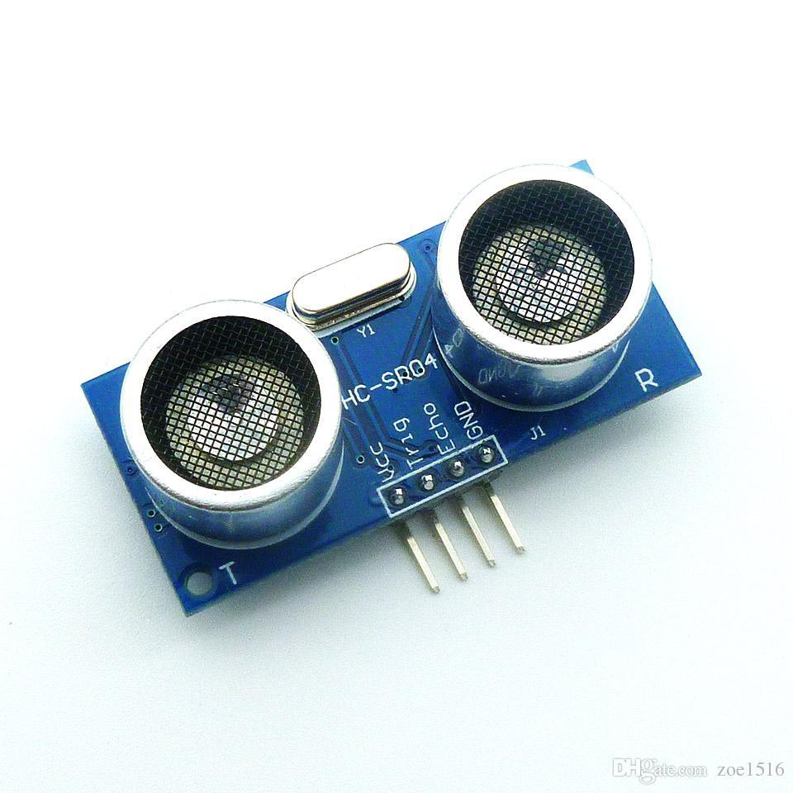***Figure 7*** the ultrasonic sensor is a device that uses ultrasonic sound waves to determine the distance to an object. In our system it use as to detect if the user's wrist is being tapped in order to obtain their body temperature.

**Figure 7. Ultrasonic Sensor**

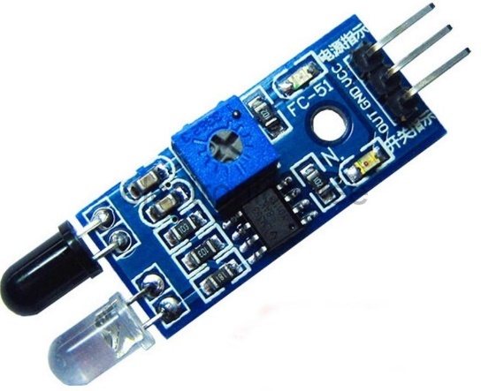***Figure 8*** The IR Sensor is used in automatic alcohol dispenser. It was designed to act as a detector on the device, and if it detects a hand within its range, it will automatically pour an alcohol.

**Figure 8. IR Sensor**

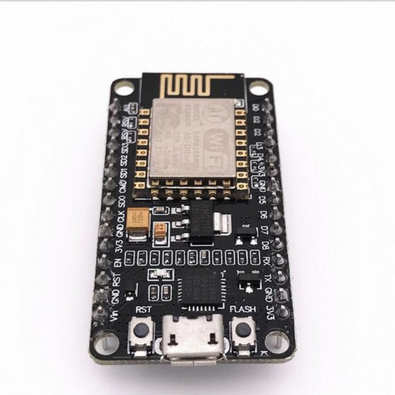***Figure 9*** ESP8266 is an open-source microcontroller board based which will conduct a username and password for the WiFi .It manage how the WiFi works. It was used by the RFID sensor MFRC522.

**Figure 9. ESP8266**

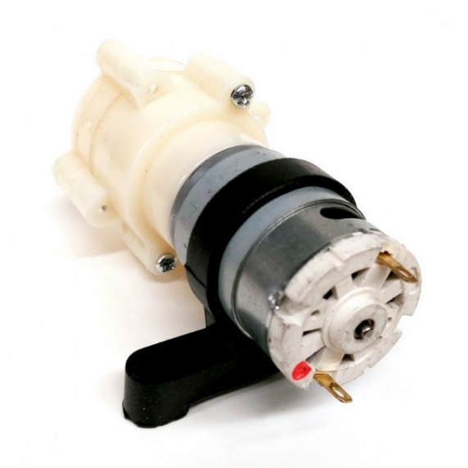***Figure 10*** displays the automatic alcohol dispenser. To pour alcohol, it was connected to an IR sensor. This device dispenses the alcohol.

**Figure 10. DC Water Pump**

**Software Interface**

Software Interface is one of the most important edge becausein this stage it describes the connections between the system and the software component tools, libraries and integrated components. i-log: RFID log monitoring system with thermal scanner utilizes Arduino Uno develop under language “c”. The Arduino Uno Software is free and downloadable to be used in variety ways, RFID ,NodeMCU and MLX90614 and Sublime Text software application that will be used in web-based development.

***Figure 11*** shows how to use the Arduino Uno software application to display the WiFi connection's generated username and password, as well as upload data to our NodeMCU and Wemos D1 boards.

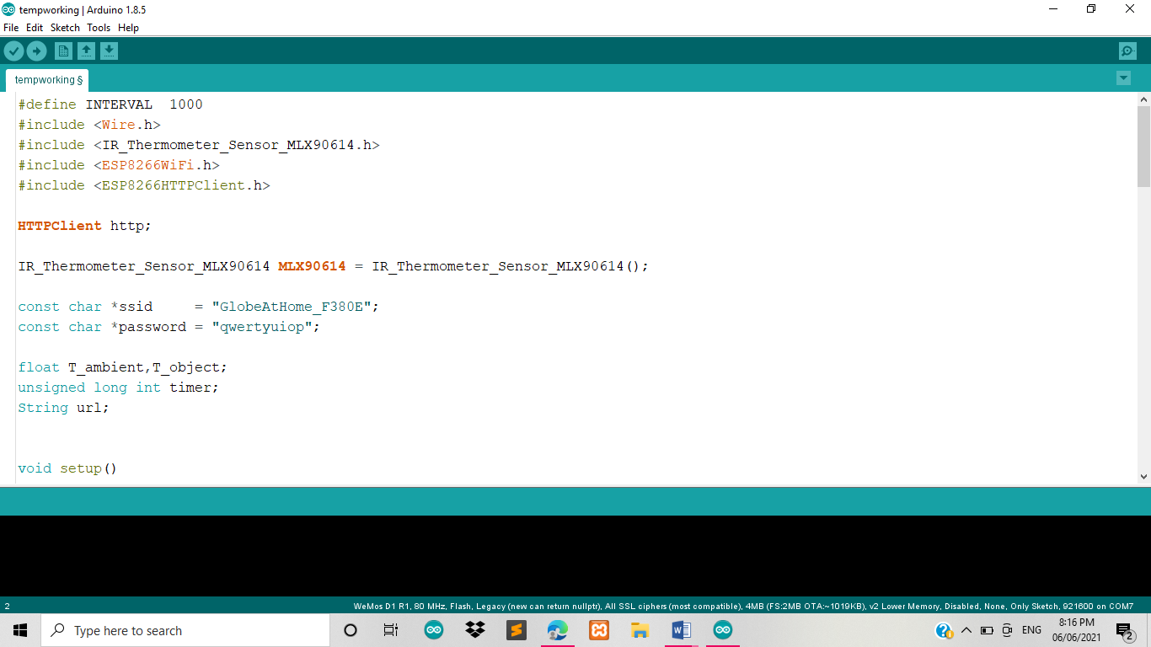

**Figure 11. Arduino Software**

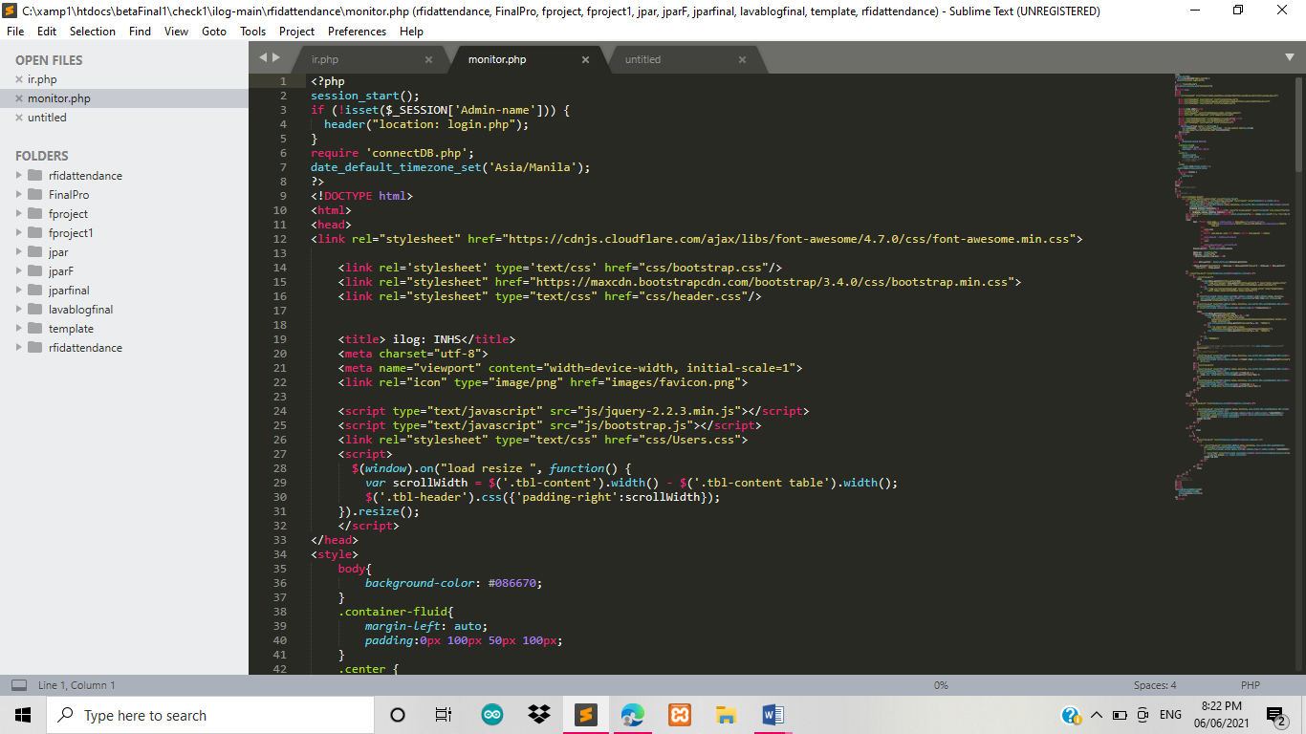***Figure 12*** shows the application of Sublime Text for web-based development.

**Figure 12. Sublime Text Software**

**Security Requirements**

The device should be kept clean and dry, and it should be secured and locked. The device can only be accessed by the admin using their unique key. Before assessing whether or not the program is secure, the researchers first assessed a security need. Only authorized personnel can access the system and log in, as some information cannot be shared with other users.

**Technical Background**

Technical background provides essential information about technicalities of the project. It makes it easier to define what is needed in terms that developers can easily understand. Hardware and software specifications are discussed below.

**Hardware Specification**

The hardware used in this project meets the required requirements in order to build this system-device. A hardware interface is included in this method, which describes the logical and physical features of each interaction between the software product and the system's hardware component. To use the system-device, administrators must first set it up and plug it into a socket. Once the device is turned on, the system will run automatically and determine whether it is functional or not.

**Software Specification**

The software interface, which explains the distinctions between the system and other software components (name and version), such as the database, operating system, tools, libraries, and integrated commercial components, is one of the most important interfaces. PHP was used for the system, Arduino for the device, the Xammp server for the database, as well as the browser was used by the proponents. In addition, the researchers used a 64-bit operating system that was capable of handling the system project.

**System Analysis and Design**

The researchers looked at the differences between a manual and an automated method. This underlines that automated systems are more capable and secure than manual systems. It is more helpful and efficient, particularly in terms of master lists, data recording, report generation and also the SMS notification.

**System Overview**

The structure and processes of Project i-log was properly planned and crafted by the project developers. Its major aim is to develop a RFID Log Monitoring System with Thermal Scanner.

**Narrative Description of the Current System**

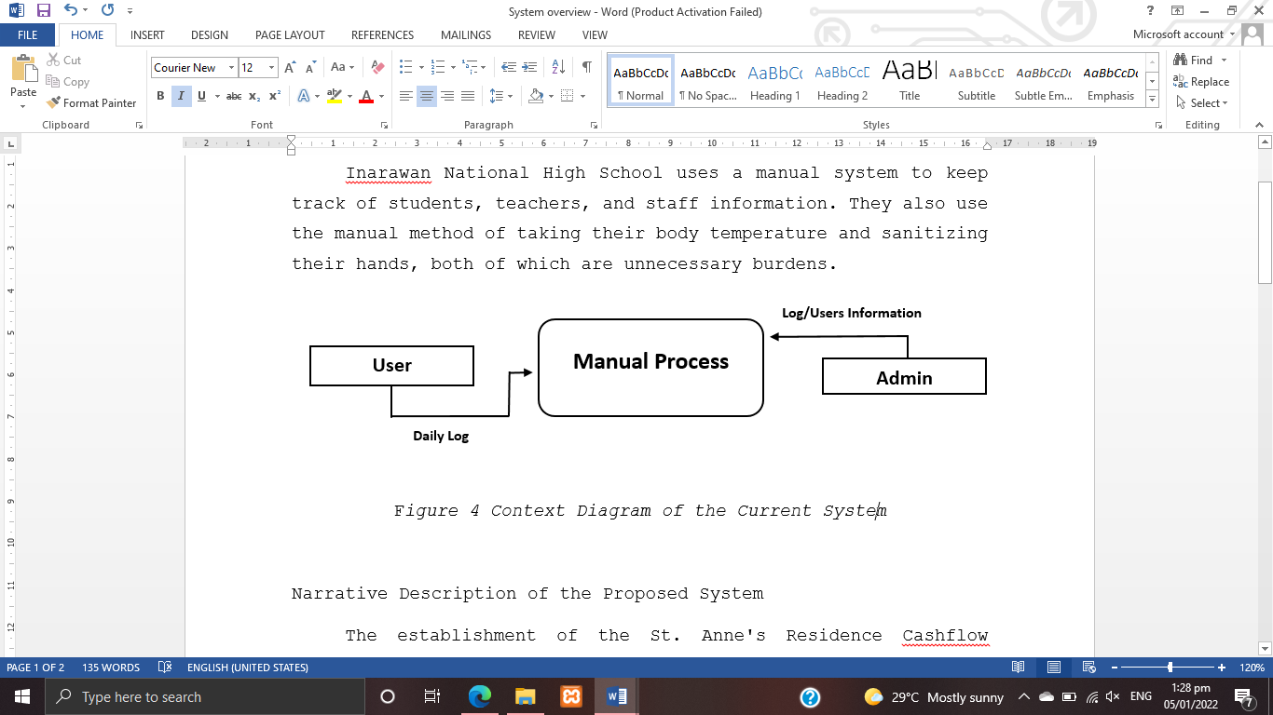***Figure 13.*** Inarawan National High School uses a manual system to keep track of students, teachers, and staff information. They also use the manual method of taking their body temperature and sanitizing their hands, both of which are unnecessary burdens.

**Figure 13. Context Diagram of the Current System**

**Narrative Description of the Proposed System**

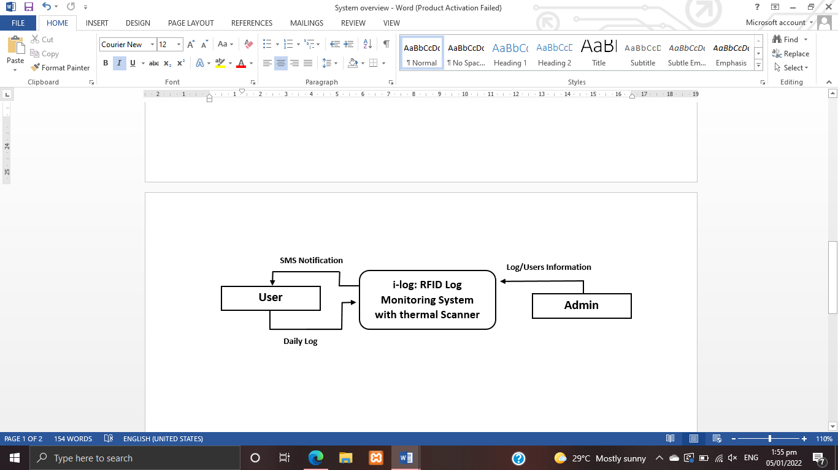***Figure 14.*** The implementation of i-log is extremely beneficial to the school in terms of tracking logs and reducing the time required by users to manually log their names and for easily notifying students' guardians and teachers' and staff's spouses if they enter the school premises. Meanwhile, an automatic alcohol dispenser is added to sanitize hands.

**Figure 14.** **Context Diagram of the Proposed System**

**System Architecture**

***Figure 15***. System Architecture is the conceptual model that defines the structure and behavior of the device. It is a formal description and representation of the device, organized in a way that supports reasoning about structures.

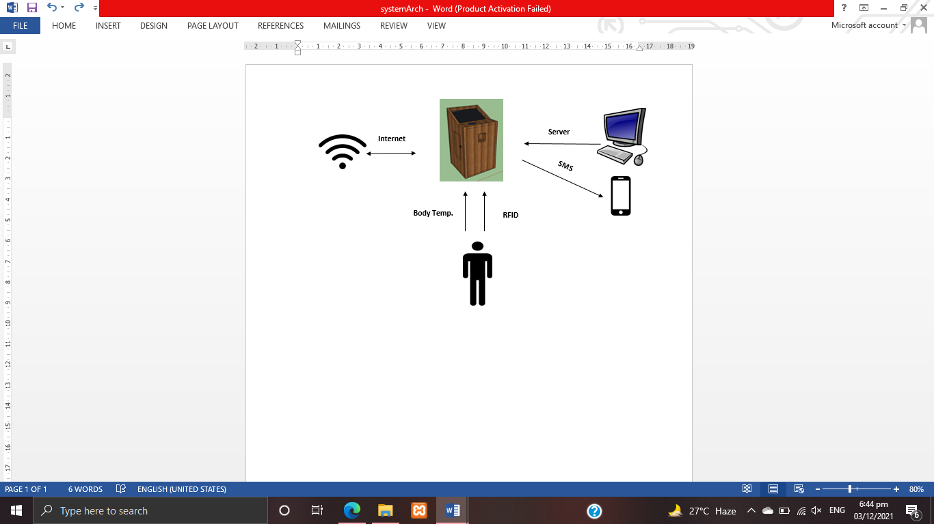

**Figure 15. System Architecture**

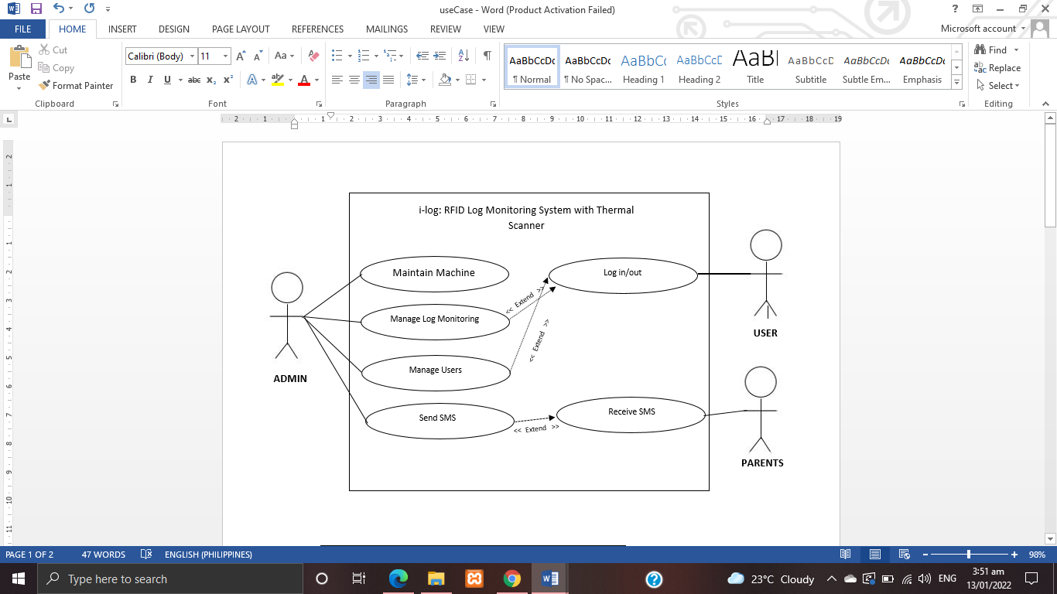***Figure 16*** presents the use case of the developed device. It shows what the admin, user and parents can do in the device.

**Figure 16.** **Use case of the developed device**

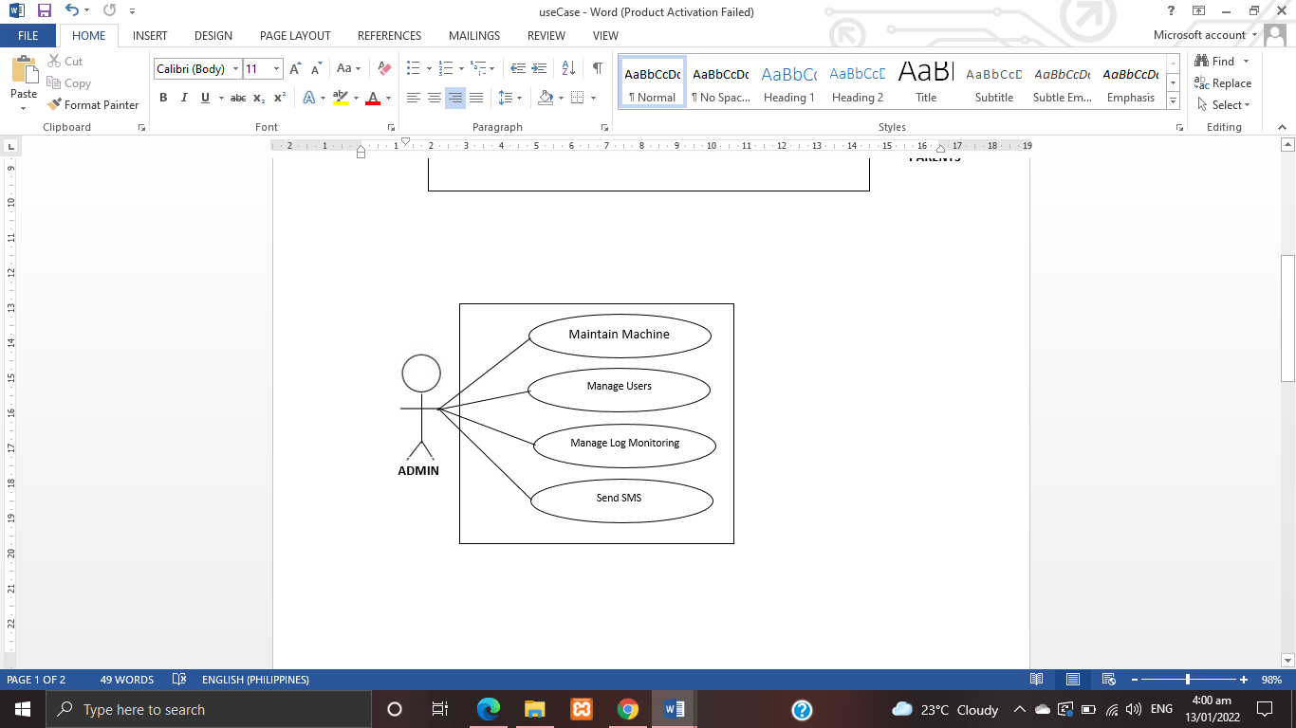***Figure 17*** shows the Use Case of the Admin of the device in which the admin is responsible of the maintenance of the device and manage the log and the users.

**Figure 17. Use case of the Admin**

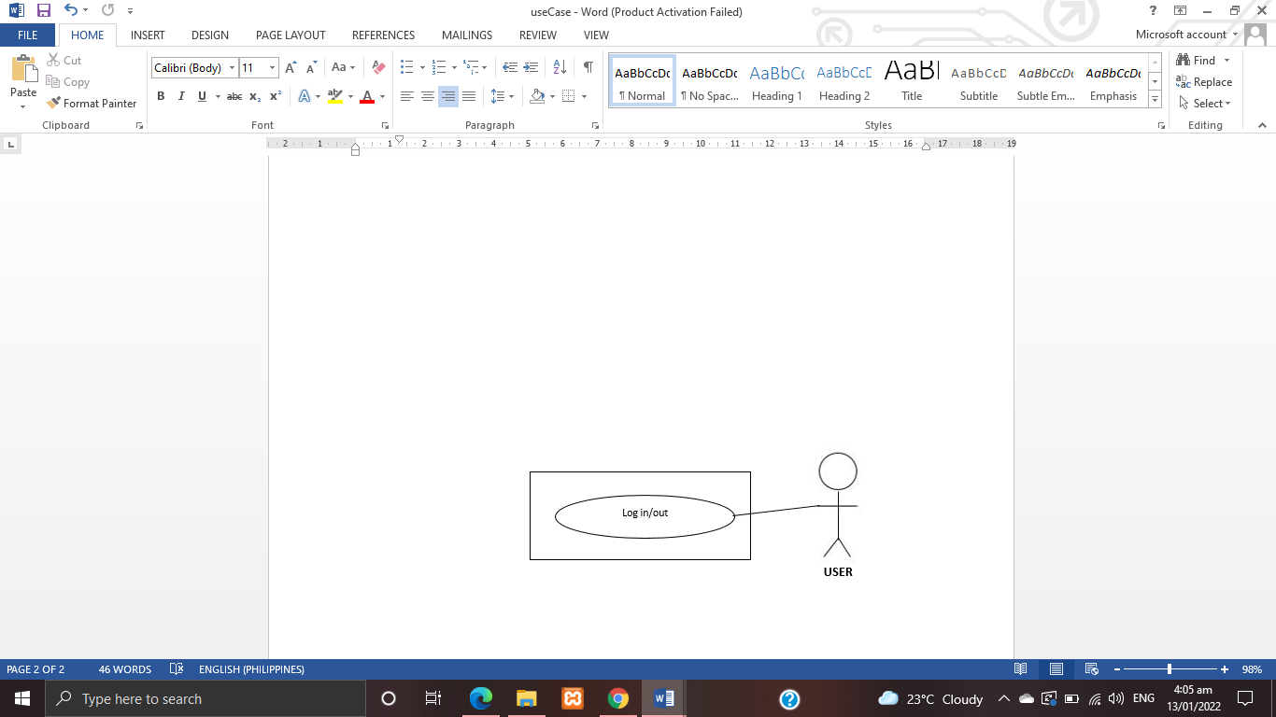***Figure 18*** show the Use Case of the user in which he/she need to tap the RFID tags and tap his wrist to log.

**Figure 18. Use case of the User**

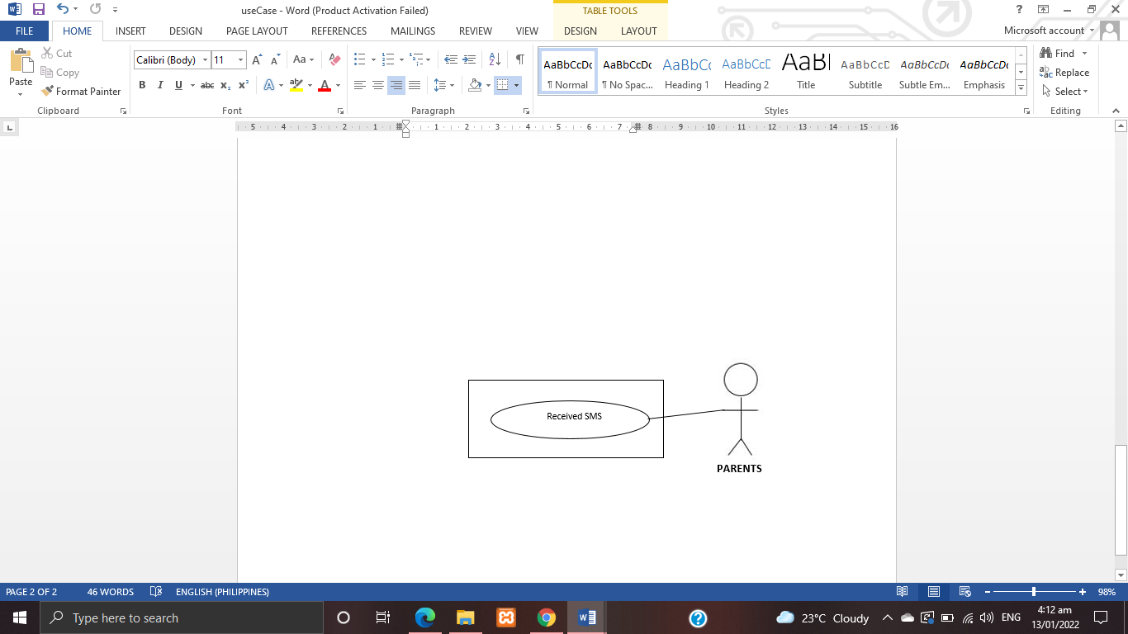***Figure 19*** show the Use Case of the parents in which they received the SMS when the users log their RFID.

**Figure 19. Use case of the Parents**

**Activity Diagram**

***Figure 20*** shows a type of diagram that represents a workflow or process. An activity diagram can also be defined as a diagrammatic representation of an algorithm, a step by step approach to solving a task.

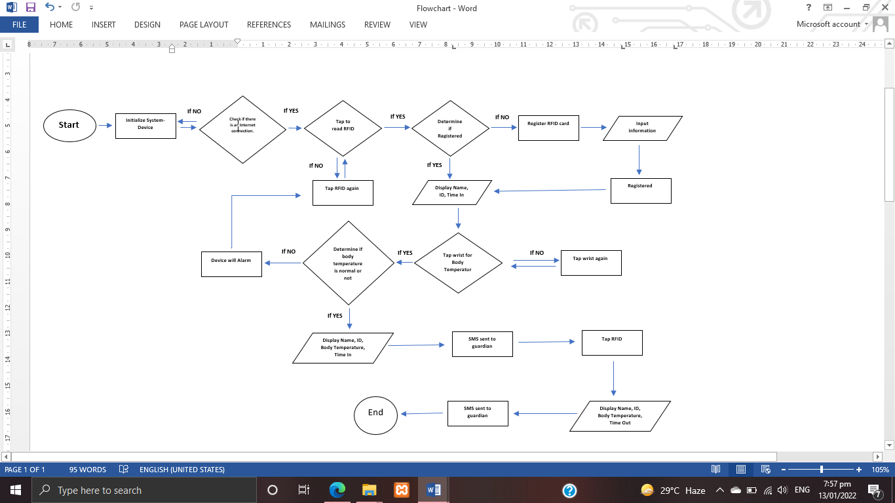

**Figure 20. Activity Diagram**

**Data Flow Diagram (DFD)**

Data flow diagram is like a map that shows the flow of information for any processes of the system/project. From here, context diagram and diagram 0 are discussed.

**Context Diagram**

***Figure 21***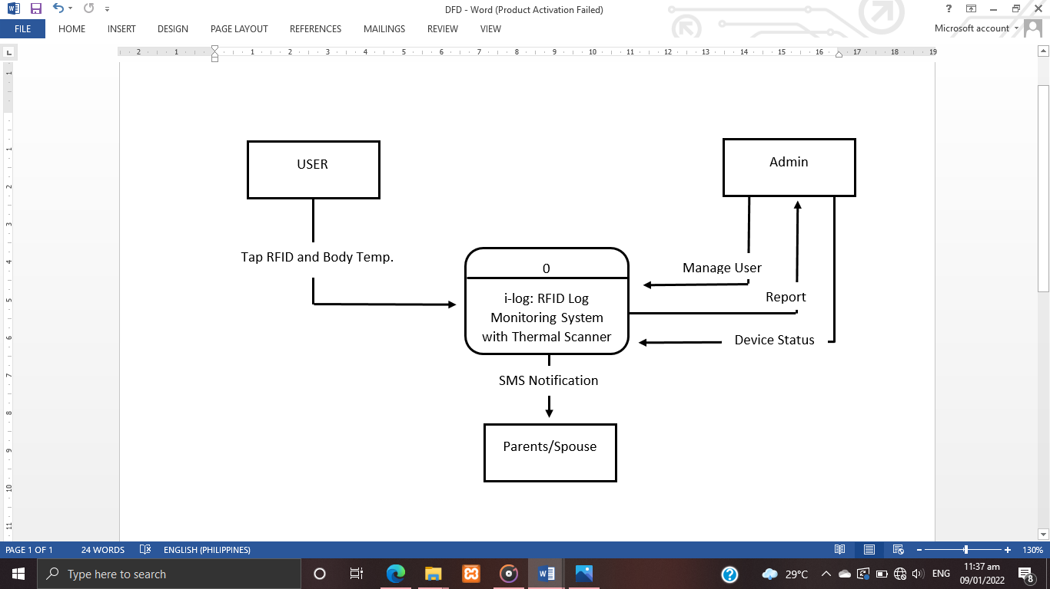is [diagram](https://en.wikipedia.org/wiki/Diagram) that defines the boundary between the [system](https://en.wikipedia.org/wiki/System), or part of a system, and its environment, showing the entities that interact with it.

**Figure 21. Context Diagram**

**Diagram 0**

***Figure 22*** diagram 0 shows the sequence of system in admin side. The system indicates all the functions that the admin can do. It includes the manage users, reports and check device. Admin can select any of the following 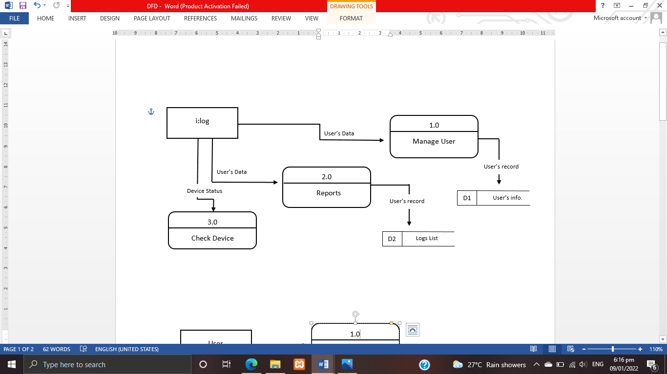base on how he need it and use the system.

**Figure 22. Diagram 0 of Admin**

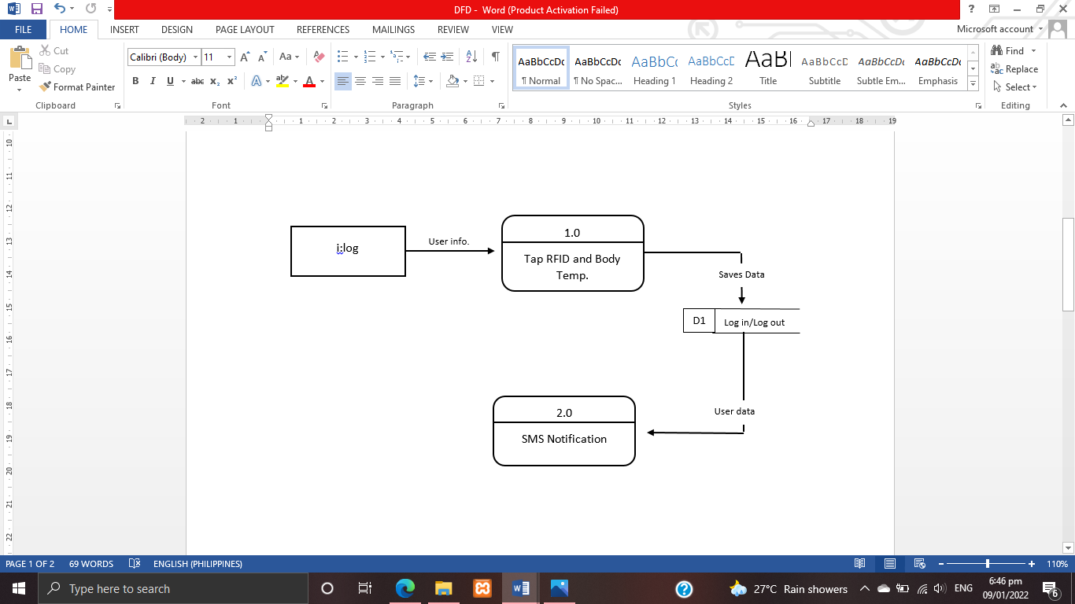***Figure 23*** diagram 0 shows the system in user’s side. The system indicates the function that the user can do. It includes the RFID and body temp and SMS notification. User can select any of the following base on how he need it and use the system.

**Figure 23. Diagram 0 of Users**

**Database Schema**

***Figure 24.*** [Database](https://en.wikipedia.org/wiki/Database) schema is a set of formulas (sentences) called [integrity constraints](https://en.wikipedia.org/wiki/Integrity_constraints) imposed on a database.

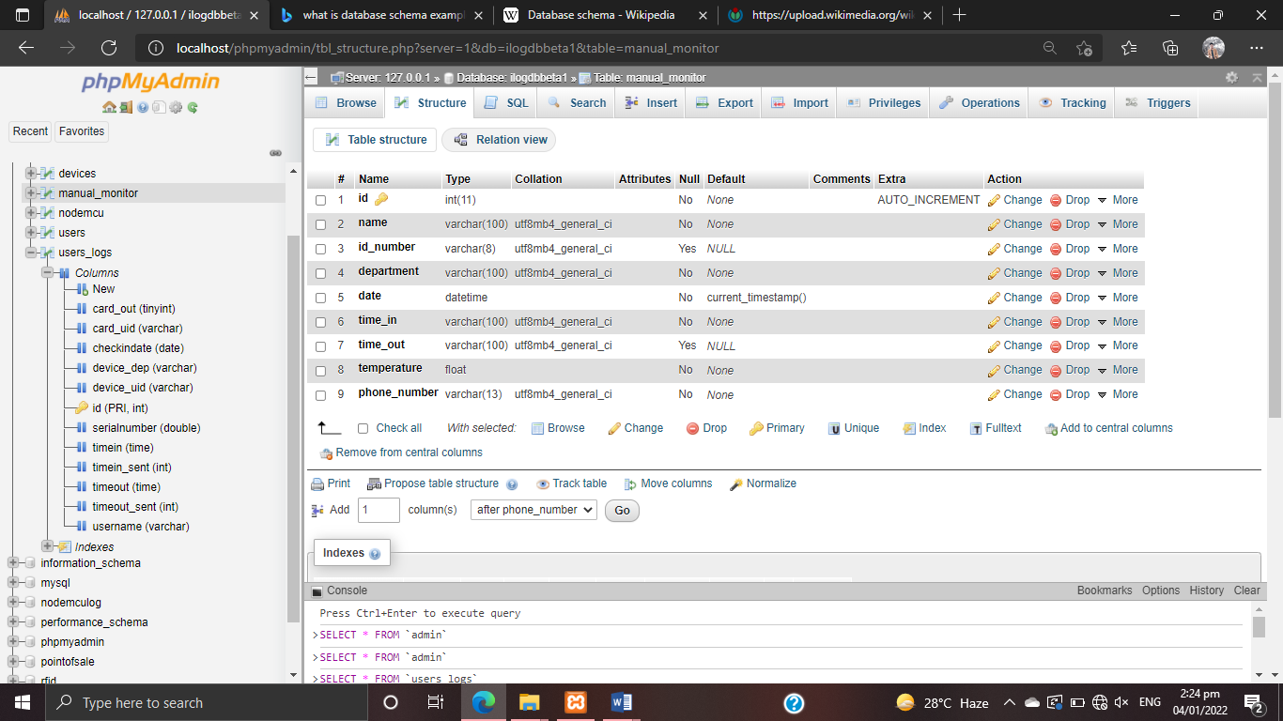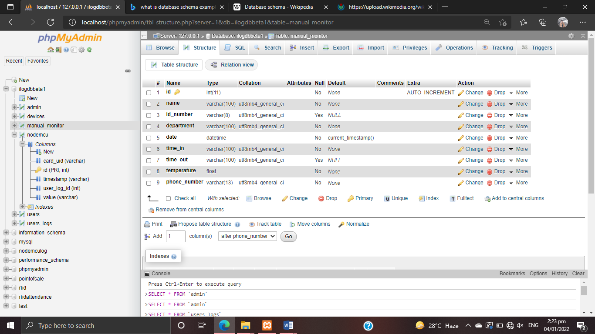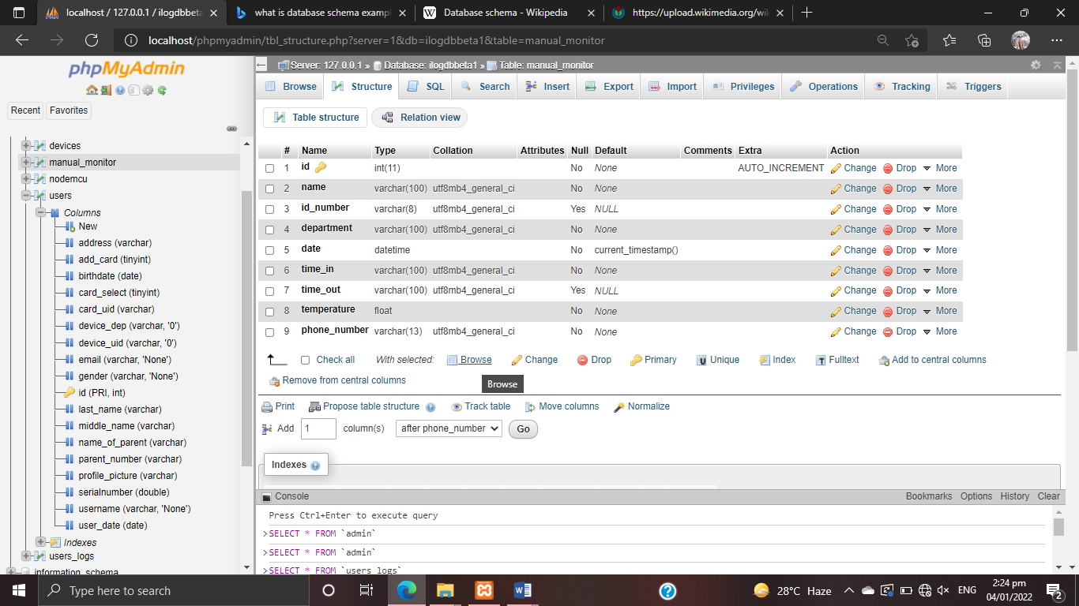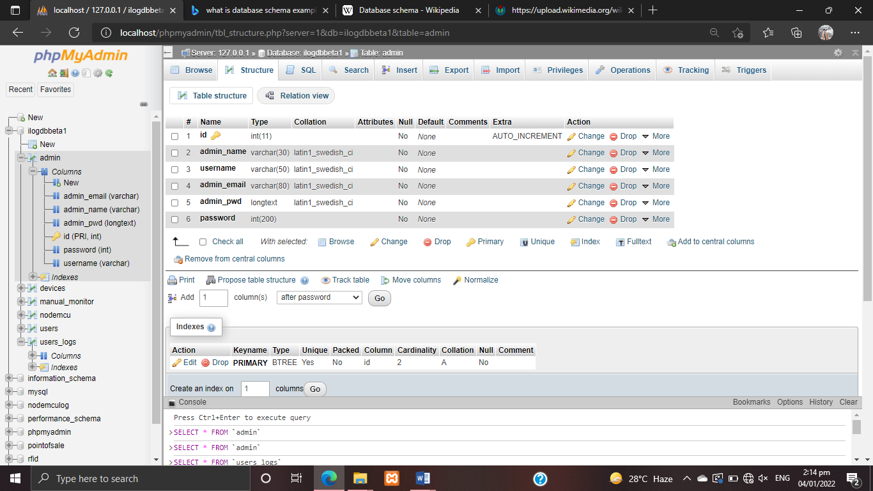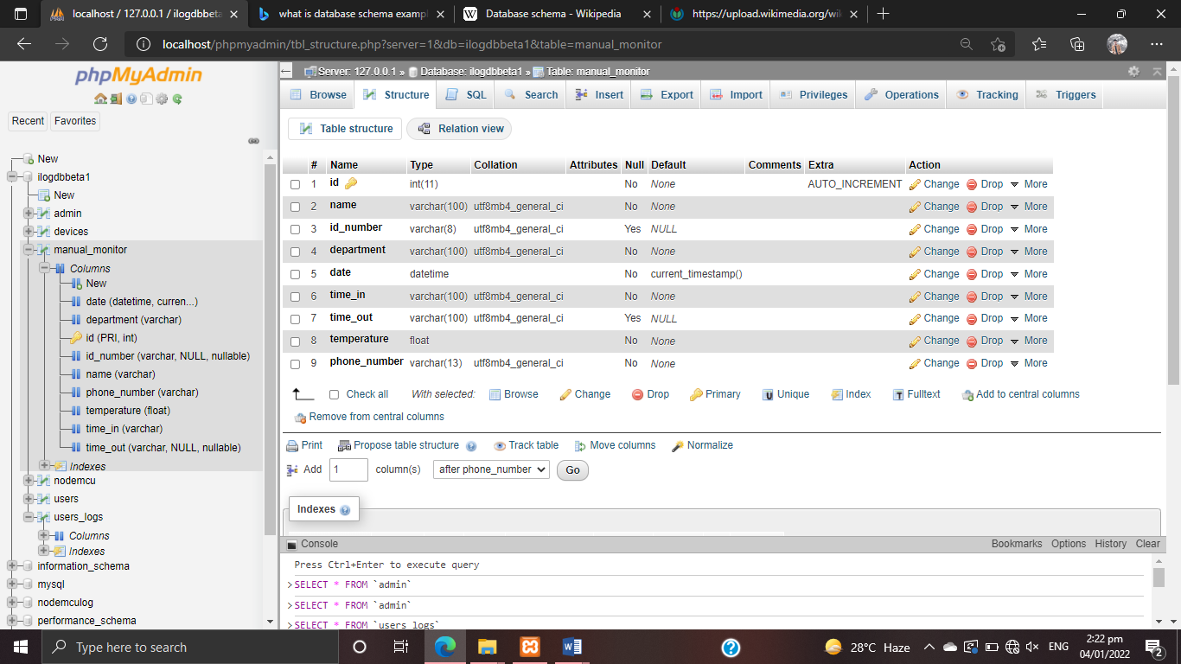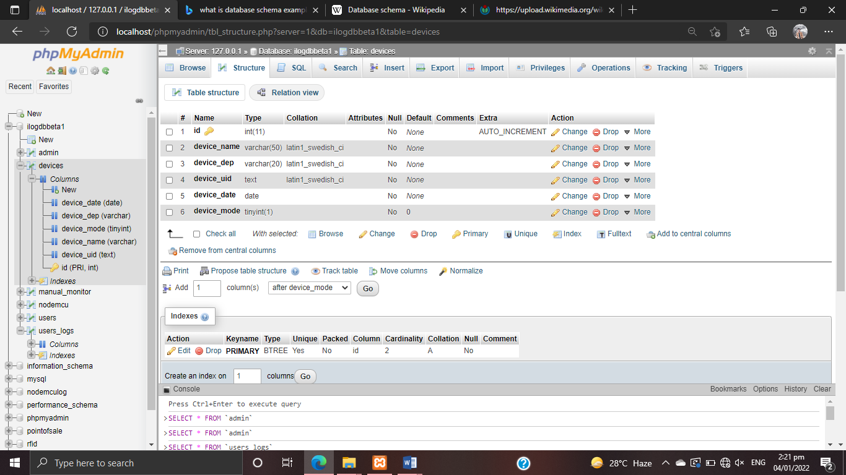

**Figure 24.** **Database Schema**

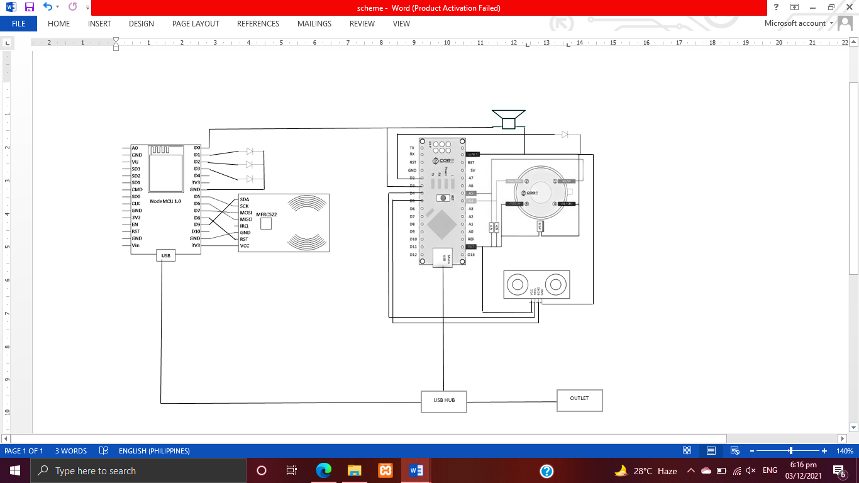***Figure 25***. Schematic Diagram it shows the representation of the elements of a device.

**Figure 25. Schematic Diagram**

**Sketch diagram**

*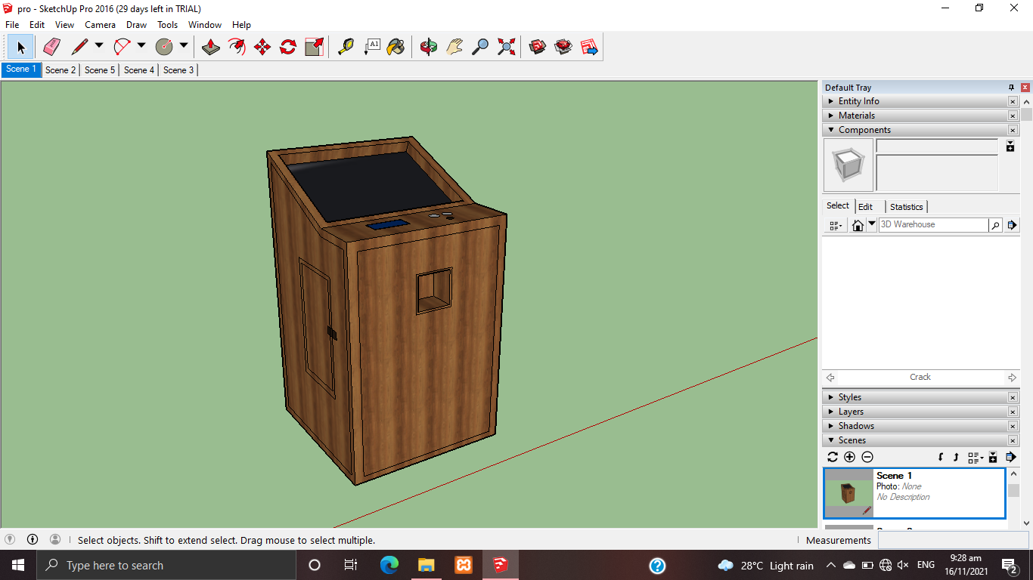****Figure 26*** shows the design and process of the developing the i-log: RFID log monitoring system with thermal scanner.

. **Figure 26. Sketch Diagram**

***Figure 27***. Sketch Diagram is a rapidly executed freehand drawing that is not intended as a finished work, often consisting of a multitude of overlapping lines while diagram is a plan, drawing, sketch or outline to show how something works, or show the relationships between the parts of a whole.

**Testing and Evaluation**

The actual testing and assessment were done to ensure that the i-log: RFID log monitoring system with thermal scanner project would find the required output and to determine the device's quality. This device also has objectives for determining the design project's execution risk. To meet the researchers' expectations and achieve the device's main purpose, they tested it multiple times to demonstrate how it works to all responders.

**Evaluation Form**

The level of performance of project i-log was evaluated using ISO 25010 criteria in terms of functional suitability, reliability, performance efficiency, usability, security, compatibility, maintainability and portability that is shown below.

**i-log: a RFID Log Monitoring System with Thermo Scanner Survey Form**

**Name (Optional) __________________________________________**

Faculty Staff IT expert others

Directions: Please answer the following questions and include the rate of the device performance honestly. Put a check (/) on the box of your corresponding answers.

1= Strongly Disagree 2= Disagree 3= Moderately Agree 4= Agree 5= Strongly Agree

|  |  |  |  |  |  |  |
| --- | --- | --- | --- | --- | --- | --- |
|  | **Questions** | 5 | 4 | 3 | 2 | 1 |
|  | **Level of Functionality Suitability** |  |  |  |  |  |
| 1. | The device functions appropriately. |  |  |  |  |  |
| 2. | The device produces accurate result and functions without errors or problems. |  |  |  |  |  |
| 3. | The device is suitable to provide an appropriate set of functions for specified tasks and user objectives. |  |  |  |  |  |
| 4. | As a whole. |  |  |  |  |  |
|  | **Level of Reliability** |  |  |  |  |  |
| 1. | The device functions a long without crashes or service interruptions. |  |  |  |  |  |
| 2. | The device re-establish a specified level of Performance in the case of a failure. |  |  |  |  |  |
| 3. | The device can be revived and become fully operational even in the event of server upgrade. |  |  |  |  |  |
| 4. | The programming can oversee as well as recuperate from part or ecological disappointment. |  |  |  |  |  |
| 5. | As a whole. |  |  |  |  |  |
|  | **Level of Performance Efficiency** |  |  |  |  |  |
| 1. | The device bears on response and process time and on through put rates in performing its functions. |  |  |  |  |  |
| 2. | The device requires minimal amount of computing resources. |  |  |  |  |  |
| 3. | The device provide appropriate performance relative to the amount of resources used under stated conditions. |  |  |  |  |  |
| 4. | As a whole. |  |  |  |  |  |
|  | **Level of Usability** |  |  |  |  |  |
| 1. | The device functions appropriately. |  |  |  |  |  |
| 2. | The device is user-friendly. For various types of users, it does not necessitate any learning effort. |  |  |  |  |  |
| 3. | The Function of the device is easily too understood. |  |  |  |  |  |
| 4. | The device produces accurate result and functions without errors or problems. |  |  |  |  |  |
| 5. | The device is suitable to provide an appropriate set of functions for specified tasks and user objectives. |  |  |  |  |  |
| 6. | The device is easy to operate. |  |  |  |  |  |
| 7. | As a whole. |  |  |  |  |  |
|  | **Level of Security** |  |  |  |  |  |



|  |  |  |  |  |  |  |
| --- | --- | --- | --- | --- | --- | --- |
| 1. | The system ensure that the data is only accessible to those who have authorized access. |  |  |  |  |  |
| 2. | The system prevent unauthorized access and modification to computer programs and data. |  |  |  |  |  |
| 3. | The action or events of the system can be proven to have taken place. |  |  |  |  |  |
| 4. | The system well identify the resource of the data. |  |  |  |  |  |
| 5. | As a whole. |  |  |  |  |  |
|  | **Level of Compatibility** |  |  |  |  |  |
| 1. | The system can perform its required functions efficiently without negatively impact to the other system. |  |  |  |  |  |
| 2. | The system-device can exchange information as well as its required function. |  |  |  |  |  |
| 3. | As a whole. |  |  |  |  |  |
|  | **Level of Maintainability** |  |  |  |  |  |
| 1. | The device enable a specified modification to be implemented. |  |  |  |  |  |
| 2. | The device can manage to device changes. |  |  |  |  |  |
| 3. | The device requires less effort for modification, fault removal or environmental failure. |  |  |  |  |  |
| 4. | Lesser effort needed to verify or a test a system change. |  |  |  |  |  |
| 5. | As a whole. |  |  |  |  |  |
|  | **Level of Portability** |  |  |  |  |  |
| 1. | The device is easy to install. |  |  |  |  |  |
| 2. | The device can easily adapt to changes such as new specifications, operations, operating environments or upgrades in system requirement. |  |  |  |  |  |
| 3. | The device allows easy exchange of given hardware component within specified environment. |  |  |  |  |  |
| 4. | As a whole. |  |  |  |  |  |

**Comments/Suggestions**___________________________________________________________________________________________________ **Signature: ___________________**

**Date: ____________________**

**Participants of the Study**

The respondents of the study were composed of 51 random people in Inarawan National High School who had used i-log. The proponents limit sample population to 51 only for the researchers to easily tabulate and interpret the collected data.

**Table 1. Respondents of the Study**

|  |  |  |
| --- | --- | --- |
| **Respondents** | **Number of Respondents** | **Percentage** |
| **Users** | **36** | **71%** |
| **IT Expert** | **15** | **29%** |
| **TOTAL** | **51** | **100%** |

***Table 1*** shows the evaluators of project i-log. The respondents are composed of users and IT experts. 71 percent of the population are users, while 29 percent are IT experts. The total number of respondents are 51 individuals.

**Data Gathering Instrument**

The developers need to distribute the validate questionnaires to acquire the needed evaluation of the respondents. Scale type of the questionnaire are 5- Strongly Agree, 4- Agree, 3-Moderately, 2- Disagree and 1- Strongly Disagree.

**Table 2. Five Point Survey Scale**

|  |  |  |
| --- | --- | --- |
| **Numerical Value** | **Statistical Limit** | **Verbal Description** |
| 5  4  3  2  1 | 4.50 – 4.99  3.50 – 4.49  2.50 – 3.49  1.50 – 2.49  1.00 – 1.49 | Strongly Agree  Agree  Moderately  Disagree  Strongly Disagree |

**Implementation Activity**

The researcher used to have an implementation plan that some individuals will protect the proposed device. They will hand over the device as well as its documentation in order to give the client a guide for the project maintenance.

|  |  |  |  |
| --- | --- | --- | --- |
| **Activities** | **No. of days** | **Start Date** | **End Date** |
| Discussion with the user | 1 | Oct. 18 2021 | Oct. 18 2021 |
| Deployment Letter | 1 | Oct. 15 2021 | Oct. 15 2021 |
| Device deployment and Maintaining Stage | 20 | Oct. 18 2021 | Nov. 12 2021 |
| Device Evaluation | 2 | Nov. 3 2021 | Nov. 8 2021 |

**Table 3. Implementation Activity**

There will be a letter of agreement that the device is handed over to the user freely and the researchers will not be responsible for the maintenance and update of the entire project. If this project is implemented, the developers will plan to conduct several strategies.

**CHAPTER IV**

**RESULTS AND DISCUSSION**

This chapter presents the process involved in the designing, testing up to the implementation plan of the system-device. The results and discussion of the development and testing are also presented in this chapter.

**Presentation of System Output**

The RFID scanner, shown in ***Figure 27***, is where users tap their RFID cards. In order to log their names into the system, users must tap their cards here. The card UID will be sent into the system once the RFID reader has read it.

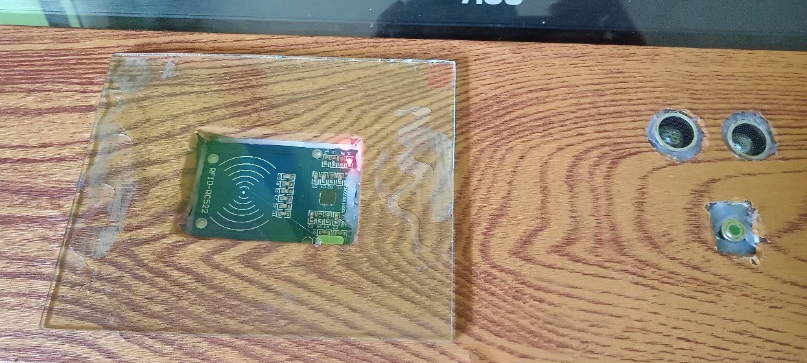

**Figure 27. RFID Scanner**

***Figure 28***, The Thermal Scanner allows users to obtain their body temperature by tapping their wrist. When the sensor detects the user's wrist, the scanner obtains the temperature and sends it to the system.

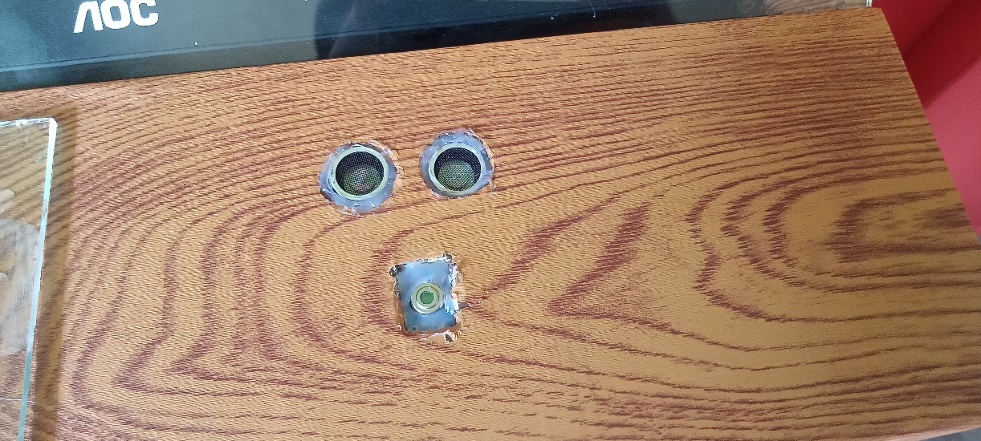

**Figure 28. Thermal Scanner**

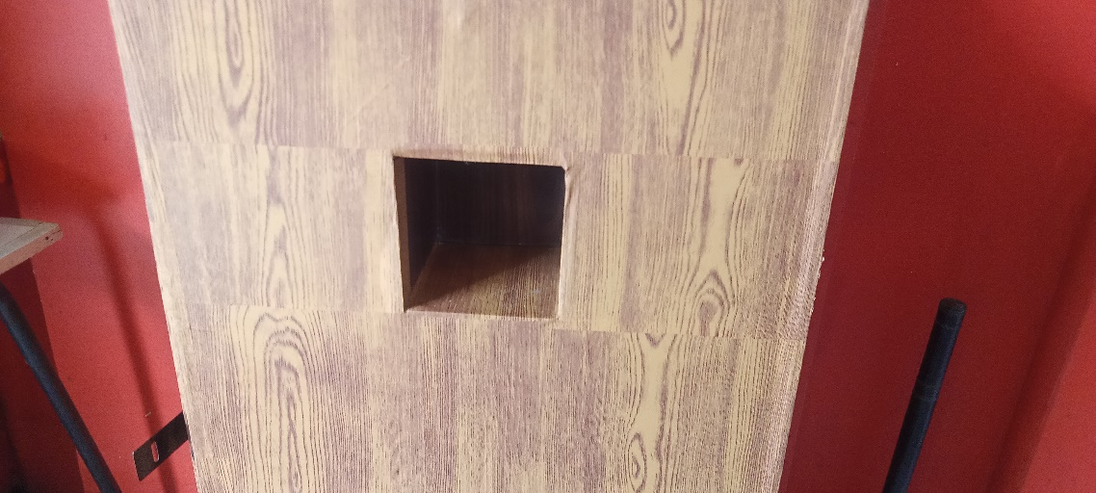***Figure 29:*** An automatic alcohol dispenser in which users can disinfect their hands by placing them in the box. When a hand enters the sensor's range, the device will immediately pour alcohol**.**

**Figure 29. Automatic Alcohol Dispenser**

***Figure 30*** shows how information is displayed when users tap their RFID and wrist. Their names, pictures, body temperatures, and the time they log are all displayed on the screen.

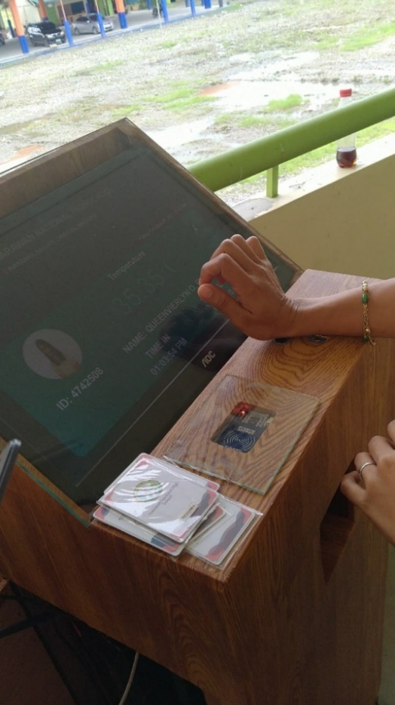

**Figure 30. The Monitor**

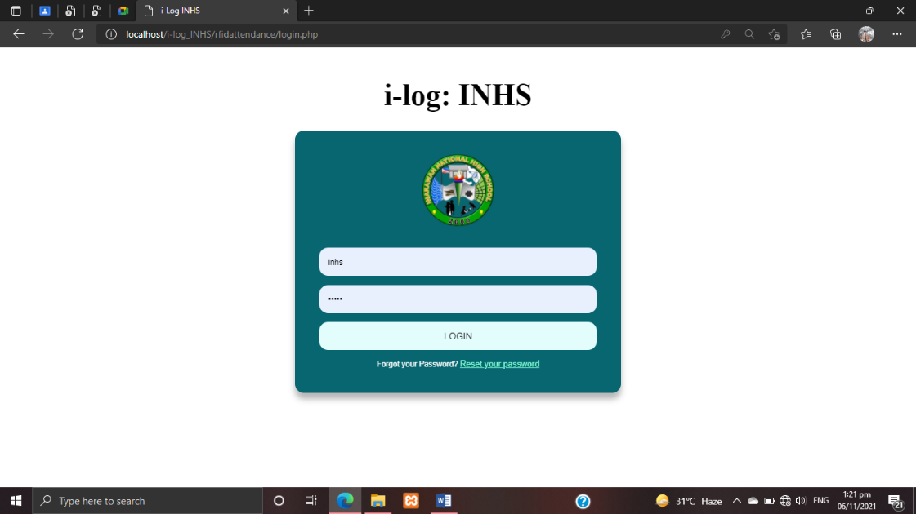***Figure 31*** shows how the admin and sub-admin can use their assigned password and email to enter into their accounts and access the system to perform their tasks. The system can only be accessed by those with a registered account. Unauthorized users who attempt to access the system will be denied access until the administrator provides their account information.

**Figure 31. Login Form**

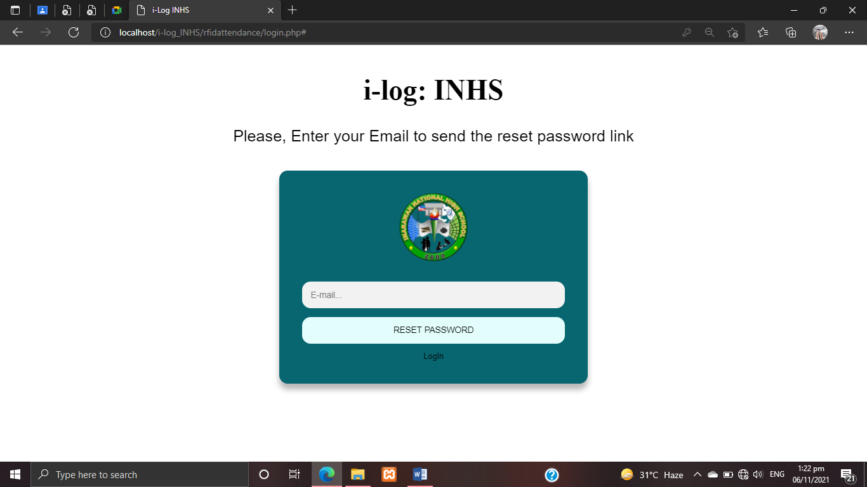***Figure 32*** shows how the admin can recover access to the system if they forget their password. The only email they can use to recover is the one they used to register with the system. A link to recover their account will be emailed to them by the system.

**Figure 32. Forgot Password Form**

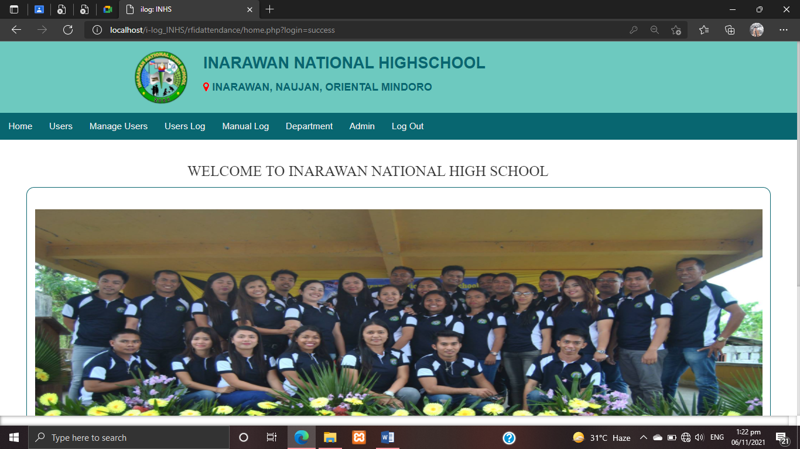As shown in ***Figure 33***, when an administrator enters the dashboard he or she can see the entire system. The admin dashboard contains possible task that the admin or the sub-admin would perform on the system.

**Figure 33. Admin Dashboard Form**

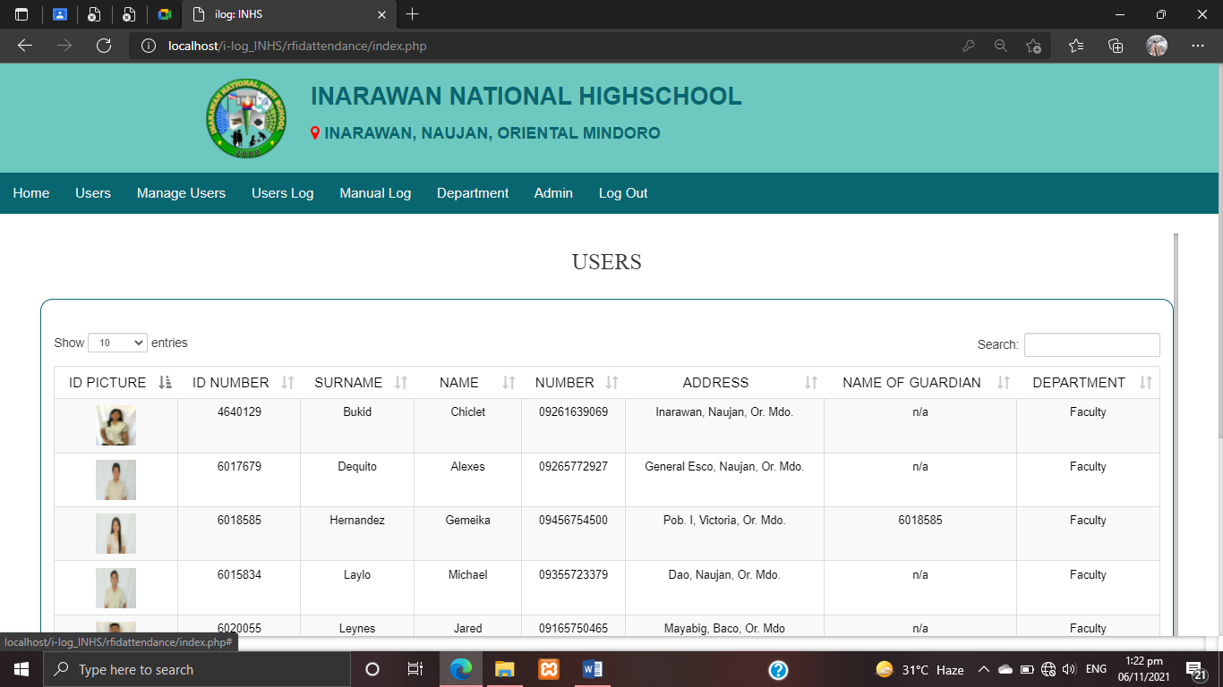 ***Figure 34*** shows the information of registered users on the system. The admin can search for users and obtain information about them using the users form. The administrator can also sort the users in ascending or descending order.

**Figure 34. Users Form**

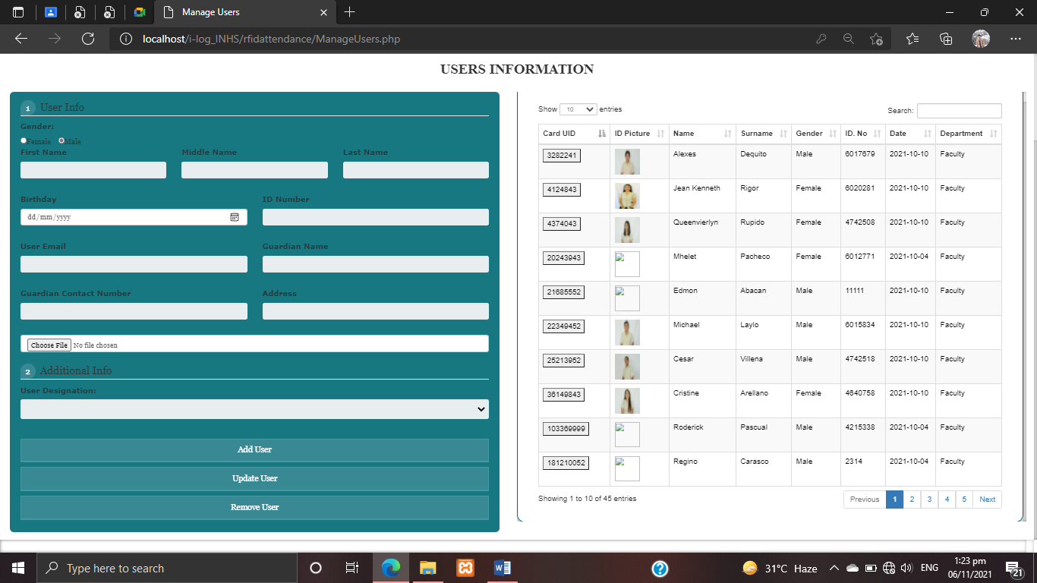***Figure 35*** shows the details of users which the admin can add, delete, update and view the information. The admin can also utilize the search box to easily locate users who need to be updated or removed.

**Figure 35. Manage Users Form**

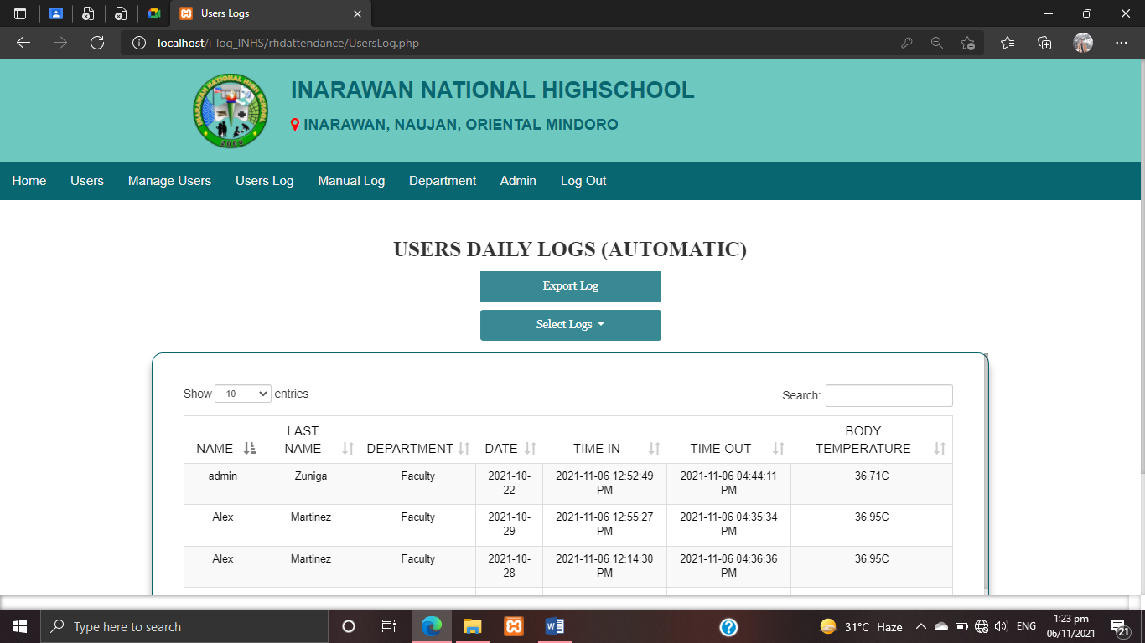Shown in ***Figure 36*** is the users’ list of RFID logs. The logs can be categorized into two categories: automatic logs (RFID) and manual logs. The user logs can be viewed by the administrator here.

**Figure 36. Users Daily Log Form (RFID)**

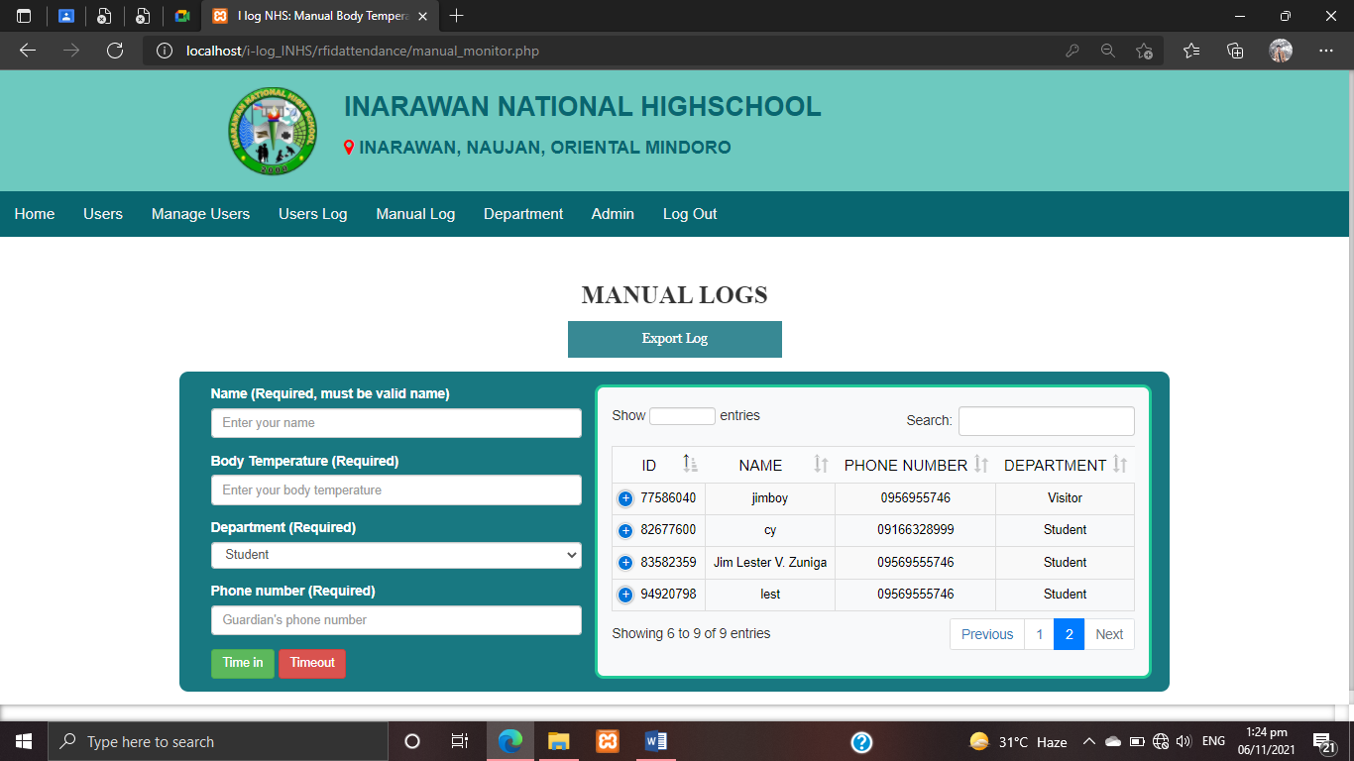As shown in ***figure 37***, the users list of manual logs. If a user forgets their RFID, the administrator can log the user here by filling out the form with the necessary information. The user manual logs can be viewed by the administrator here.

**Figure 37. Users Daily Log Form (Manual)**

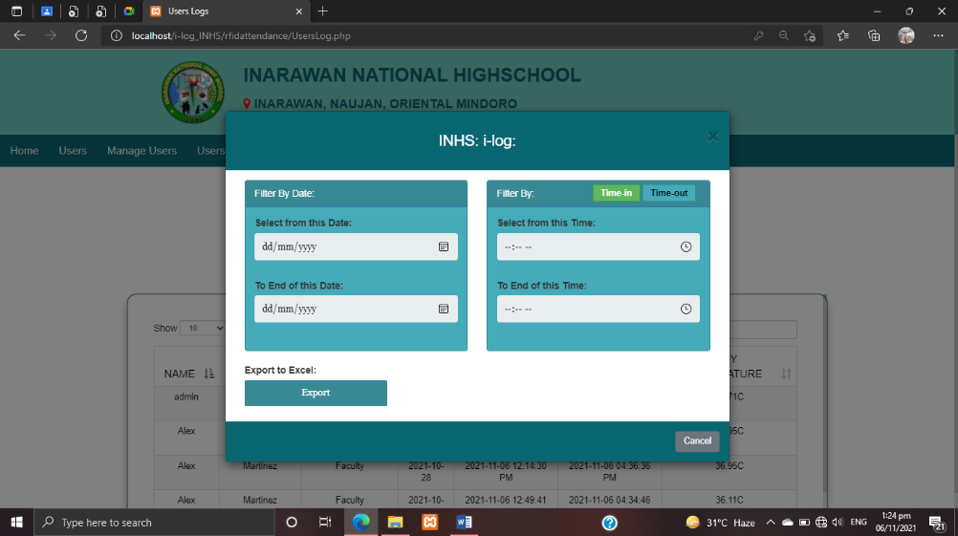***Figure 38*** shows that the system has the ability to filter by date and time, as well as export the filtered data. Whether it's time in or time out, the admin can also choose what he wants to filter. The filtered data will be exported and saved as an excel spreadsheet.

**Figure 38. Export Data Form**

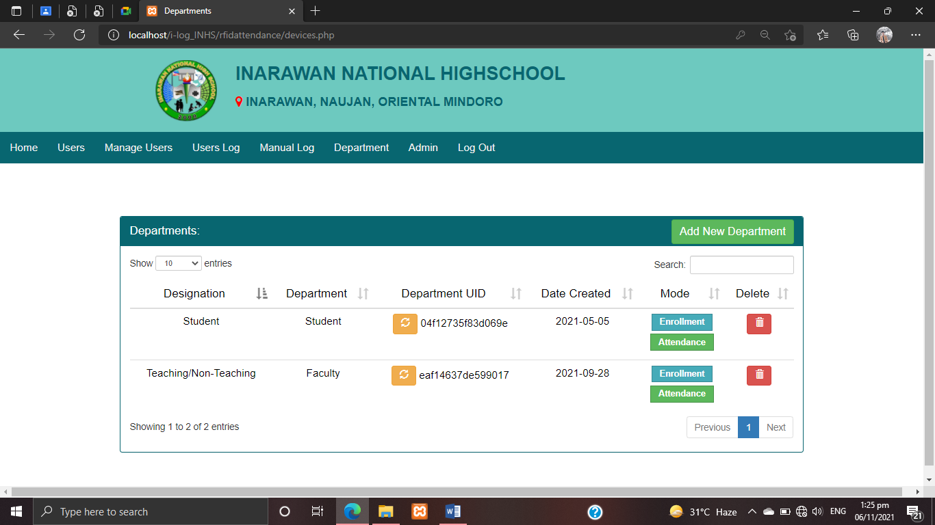***Figure 39*** shows the system mode when it is on attendance or enrollment. On that selection, the admin can choose the mode. The admin can create a department for the users to be allocated to on this page.

**Figure 39. Department Form**

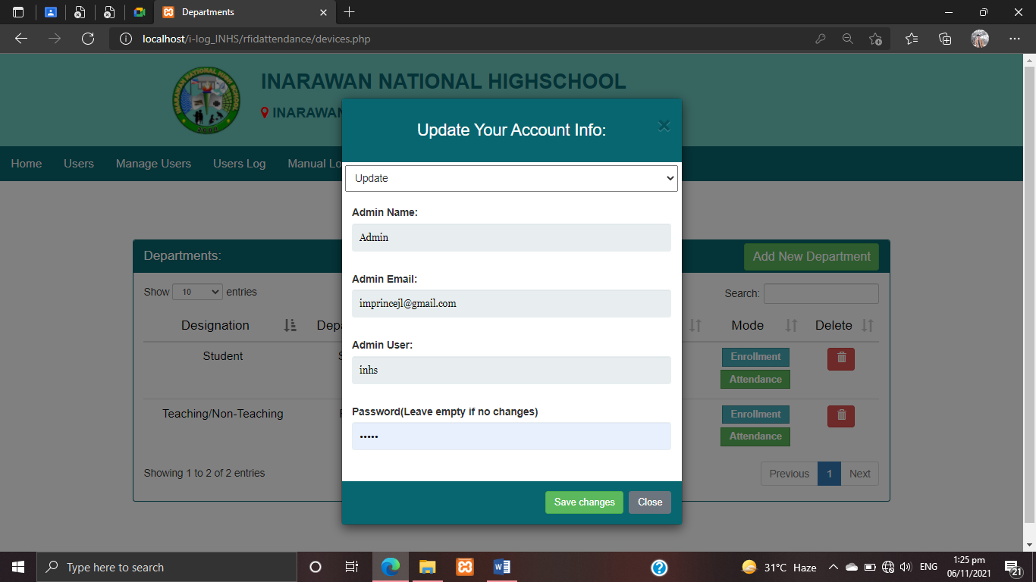***Figure 40*** shows that the admin can update, register and delete their account in order for them to access the system and perform their desired transaction.

**Figure 40. Account Form**

**Evaluation of the System**

In the implementation plan of the system-device, an evaluation was conducted to test the quality standard of the system-device using ISO 25010 **in** terms of functionality, reliability, performance efficiency, usability, security, compatibility, maintainability and portability. This was evaluated by IT experts and users.

**Implementation Results**

**Level of Performance In Terms of Functionality**

**Table 4. Level of Functionality of the User and IT Expert**

|  |  |  |  |  |
| --- | --- | --- | --- | --- |
| **Items** | **Device User** | | **IT Expert** | |
|
| **WM** | **VD** | **WM** | **VD** |
| 1. The device functions appropriately | 4.86 | SA | 5 | SA |
| 2. The device produces accurate result and functions without errors or problems. | 4.91 | SA | 4.93 | SA |
| 3. The device is suitable to provide an appropriate set of functions for specified tasks and user objectives | 4.77 | SA | 4.8 | SA |
| 4. As a whole. | 4.88 | SA | 4.93 | SA |
| **Overall Mean:** | **4.86** | **SA** | **4.91** | **SA** |

*4.50 – 5.00 = Strongly Agree, 3.50 – 4.49 = Agree, 2.50 – 3.49 Moderately, 1.50 – 2.49 Disagree, 1.00 – 1.49 Strongly Disagree*

***Table 4*** shows the respondents rating in the given question about functionality of the device to carry out its required functions. As shown, the device was rated by the device users (M = 4.86) as “Strongly Agree” and the experts (M= 4.91) as “Strongly Agree”.

It implies that the respondents believe that the device is functional because it produces accurate results without any error as well as its functions appropriately according to its specifications.

**Level of Performance In Terms of Reliability**

**Table 5. Level of Reliability of the User and IT Expert**

|  |  |  |  |  |
| --- | --- | --- | --- | --- |
| **Items** | **Device User** | | **IT Expert** | |
|
| **WM** | **VD** | **WM** | **VD** |
| 1. The device functions a long without crashes or service interruptions. | 4.72 | SA | 4.8 | SA |
| 2. The device re-establish a specified level of Performance in the case of a failure | 4.83 | SA | 4.93 | SA |
| 3. The device can be revived and become fully operational even in the event of server upgrade. | 4.77 | SA | 4.73 | SA |
| 4. The programming can oversee as well as recuperate from part or ecological disappointment. | 4.58 | SA | 4.86 | SA |
| 5. As a whole. | 4.94 | SA | 4.86 | SA |
| **Overall Mean:** | **4.77** | **SA** | **4.84** | **SA** |

*4.50 – 5.00 = Strongly Agree, 3.50 – 4.49 = Agree, 2.50 – 3.49 Moderately, 1.50 – 2.49 Disagree, 1.00 – 1.49 Strongly Disagree*

As shown in ***table 5*** in terms of reliability, the device was rated by users (M= 4.77) as “Strongly Agree” and the experts (M= 4.84) as “Strongly Agree”. This means that the device has the ability to maintain service and withstand the factors that may affect it. The respondents were satisfied of the device developed by the researcher.

This implies that the device can perform its functions without any interruption. The users can also rely on the device.

As shown in ***table 5***, the overall result of the evaluation is “Strongly Agree” proving that the device can perform its services and can manage to recover in the event of environmental failure, and the users can rely on its services.

**Level of Performance In Terms of Efficiency**

**Table 6. Level of Efficiency of the User and IT Expert**

|  |  |  |  |  |
| --- | --- | --- | --- | --- |
| **Items** | **Device User** | | **IT Expert** | |
|
| **WM** | **VD** | **WM** | **VD** |
| 1. The device bears on response and process time and on through put rates in performing its functions. | 4.88 | SA | 4.73 | SA |
| 2. The device requires minimal amount of computing resources. | 4.80 | SA | 4.6 | SA |
| 3. The device provide appropriate performance relative to the amount of resources used under stated conditions. | 4.72 | SA | 4.8 | SA |
| 4. As a whole. | 4.94 | SA | 4.86 | SA |
| **Overall Mean:** | **4.84** | **SA** | **4.75** | **SA** |

*4.50 – 5.00 = Strongly Agree, 3.50 – 4.49 = Agree, 2.50 – 3.49 Moderately, 1.50 – 2.49 Disagree, 1.00 – 1.49 Strongly Disagree*

As shown in ***table 6*** in terms of efficiency, the system-device was rated by IT Experts (M = 4.75) as “Strongly Agree”, Users (M = 4.84) as “Strongly Agree”. This means that the device performance was not affected by the amount of resources utilization and could continue to deliver its function under certain conditions.

The result signify that the device can continue to deliver its function under certain conditions and it is not affected by the amount of resource utilization.

As shown in ***table 6***, the respondents evaluated the system-device as “Strongly Agree” which shows that the respondent believe that the device could continue to deliver its functions under certain conditions and cater to multiple and parallel inquiries.

**Level of Performance In Terms of Usability**

**Table 7. Level of Usability of the User and IT Expert**

|  |  |  |  |
| --- | --- | --- | --- |
| **Items** | **Device User** | **IT Expert** | |
|  | |  | | |
| **WM** | **VD** | **WM** | | **VD** |
| 1. The device functions appropriately. | 4.86 | SA | 4.93 | | SA |
| 2. The device is user-friendly. For various types of users, it does not necessitate any learning effort. | 4.75 | SA | 4.73 | | SA |
| 3. The Function of the device is easily too understood. | 4.69 | SA | 4.8 | | SA |
| 4. The device produces accurate result and functions without errors or problems. | 4.69 | SA | 4.86 | | SA |
| 5. The device is suitable to provide an appropriate set of functions for specified tasks and user objectives. | 4.66 | SA | 4.73 | | SA |
| 6. The device is easy to operate. | 4.77 | SA | 5 | | SA |
| 7. As a whole | 4.88 | SA | 4.86 | | SA |
| **Overall Mean:** | **4.76** | **SA** | **4.84** | | **SA** |

*4.50 – 5.00 = Strongly Agree, 3.50 – 4.49 = Agree, 2.50 – 3.49 Moderately, 1.50 – 2.49 Disagree, 1.00 – 1.49 Strongly Disagree*

As shown in ***table 7***, in terms of usability, the device was rated by the IT Experts (M = 4.84), and user (M = 4.76) as “Strongly Agree”. This means that the device is highly usable and the device is easy to operate. It also means that different types of users could use the device easily. It does not require technical skill and sophisticated learning efforts on the part of different types of users in order to make use of the device. This implies the device is user-friendly, and easy to operate.

As shown in ***table 7***, the respondents evaluation on the usability of the device is ‘Strongly Agree’, proving that the device is easy to operate and the respondents find it easy to use without the need for technical skills.

**Level of Performance In Terms of Security**

**Table 6. Level of Security of the User and IT Expert**

|  |  |  |  |
| --- | --- | --- | --- |
| **Items** | **Device User** | **IT Expert** | |
|  | |  | | |
| **WM** | **VD** | **WM** | | **VD** |
| 1. The system ensure that the data is only accessible to those who have authorized access | 4.75 | SA | 4.73 | | SA |
| 2. The system prevent unauthorized access and modification to computer programs and data. | 4.75 | SA | 4.86 | | SA |
| 3. The action or events of the system can be proven to have taken place | 4.72 | SA | 4.73 | | SA |
| 4. The system well identify the resource of the data. | 4.80 | SA | 4.93 | | SA |
| 5. As a whole | 4.91 | SA | 4.86 | | SA |
| **Overall Mean:** | **4.78** | **SA** | **4.82** | | **SA** |

*4.50 – 5.00 = Strongly Agree, 3.50 – 4.49 = Agree, 2.50 – 3.49 Moderately, 1.50 – 2.49 Disagree, 1.00 – 1.49 Strongly Disagree*

***Table 8*** shows that Security of this device was rated (M = 4.78) as “Strongly Agree” by the users and (M = 4.82) as “Strongly Agree by the experts.

Based on the result, the respondents believe that the device has a high security. It also proves that only the authorized person can access the system of the device.

**Level of Performance In Terms of Compatibility**

**Table 9. Level of Compatibility of the User and IT Expert**

|  |  |  |  |  |
| --- | --- | --- | --- | --- |
| **Items** | **Device User** | | **IT Expert** | |
|
| **WM** | **VD** | **WM** | **VD** |
| 1. The system can perform its required functions efficiently without negatively impact to the other system. | 4.75 | SA | 4.93 | SA |
| 2. The system-device can exchange information as well as its required function | 4.83 | SA | 4.86 | SA |
| 3. As a whole | 4.91 | SA | 4.86 | SA |
| **Overall Mean:** | **4.83** | **SA** | **4.88** | **SA** |

*4.50 – 5.00 = Strongly Agree, 3.50 – 4.49 = Agree, 2.50 – 3.49 Moderately, 1.50 – 2.49 Disagree, 1.00 – 1.49 Strongly Disagree*

***Table 9*** shows that the Compatibility of this device was rated (M = 4.83) as “Strongly Agree” by the users and (M = 4.88) as “Strongly Agree” by the experts.

Based on the result, the respondents believe that the device can exchange information as well as perform its required functions while sharing the same hardware or software environment.

**Level of Performance In Terms of Maintainability**

**Table 10. Level of Maintainability of the User and IT Expert**

|  |  |  |  |  |
| --- | --- | --- | --- | --- |
| **Items** | **Device User** | | **IT Expert** | |
|
| **WM** | **VD** | **WM** | **VD** |
| 1. The device enable a specified modification to be implemented. | 4.75 | SA | 4.93 | SA |
| 2. The device can manage to device changes. | 4.86 | SA | 4.86 | SA |
| 3. The device requires less effort for modification, fault removal or environmental failure. | 4.72 | SA | 4.73 | SA |
| 4. Lesser effort needed to verify or a test a system change. | 4.80 | SA | 4.6 | SA |
| 5. As a whole | 4.91 | SA | 4.8 | SA |
| **Overall Mean:** | **4.81** | **SA** | **4.78** | **SA** |

*4.50 – 5.00 = Strongly Agree, 3.50 – 4.49 = Agree, 2.50 – 3.49 Moderately, 1.50 – 2.49 Disagree, 1.00 – 1.49 Strongly Disagree*

As shown in ***table 10*** in terms of maintainability, the device was rated by IT Experts (M = 4.78) and Users (M = 4.81) as “Strongly Agree “and. This means the respondents believed that the device could easily adopt to changes such as new specifications, operating environments or upgrade in system requirement without affecting its operation.

It implies that the device requires less effort to maintain and the services would not be affected during the maintenance period. This further implies that the device had the ability to report the root cause of failure, it can manage the system changes, it requires less effort for fault removal or environmental change and it requires minimal effort to test a system changes.

As shown in ***table 10***, the result of evaluation, the respondents rated it as “Strongly Agree”, and it shows that the system-device could not be easily affected by the system updates.

**Level of Performance In Terms of Portability**

**Table1 11. Level of Portability of the User and IT Expert**

|  |  |  |  |  |
| --- | --- | --- | --- | --- |
| **Items** | **Device User** | | **IT Expert** | |
|
| **WM** | **VD** | **WM** | **VD** |
| 1. The device is easy to install. | 4.66 | SA | 4.73 | SA |
| 2. The device can easily adapt to changes such as new specifications, operations, operating environments or upgrades in system requirement. | 4.83 | SA | 4.66 | SA |
| 3. The device allows easy exchange of given hardware component within specified environment. | 4.75 | SA | 4.86 | SA |
| 4. As a whole | 4.88 | SA | 4.93 | SA |
| **Overall Mean:** | **4.78** | **SA** | **4.8** | **SA** |

*4.50 – 5.00 = Strongly Agree, 3.50 – 4.49 = Agree, 2.50 – 3.49 Moderately, 1.50 – 2.49 Disagree, 1.00 – 1.49 Strongly Disagree*

As shown in ***table 11*** in terms of portability, the device was rated by the IT Experts (M = 4.8) and Users (M = 4.78) as Strongly Agree”. This means that the device is highly portable, could easily adopt to changes such as new specification, operating environment or upgrades in system requirements without affecting its operation and can be installed easily.

It implies that the users can manipulate and use the device developed by the researcher. Furthermore, users believed that it can conform to industry standard of the present technology.

According to the results, this device will be portable for the users.

**Summary Table**

**Table 12. Properties of Evaluation as a Whole**

|  |  |  |  |  |  |  |
| --- | --- | --- | --- | --- | --- | --- |
| **Items** | **Device User** | | **IT Expert** | | **Entire Group** | |
| **User** | **VD** | **WM** | **VD** | **WM** | **VD** |
| **FUNCTIONALITY** | **4.86** | **SA** | **4.91** | **SA** | **4.88** | **SA** |
| **RELIABILITY** | **4.77** | **SA** | **4.84** | **SA** | **4.80** | **SA** |
| **PERFORMANCE EFFICIENCY** | **4.84** | **SA** | **4.75** | **SA** | **4.79** | **SA** |
| **USABILITY** | **4.76** | **SA** | **4.84** | **SA** | **4.8** | **SA** |
| **SECURITY** | **4.78** | **SA** | **4.82** | **SA** | **4.8** | **SA** |
| **COMPATIBILITY** | **4.83** | **SA** | **4.88** | **SA** | **4.85** | **SA** |
| **MAINTAINABILITY** | **4.81** | **SA** | **4.78** | **SA** | **4.79** | **SA** |
| **PORTABILITY** | **4.78** | **SA** | **4.8** | **SA** | **4.79** | **SA** |
| **OVERALL MEAN** | **4.80** | **SA** | **4.82** | **SA** | **4.81** | **SA** |

*4.50 – 5.00 = Strongly Agree, 3.50 – 4.49 = Agree, 2.50 – 3.49 Moderately, 1.50 – 2.49 Disagree, 1.00 – 1.49 Strongly Disagree*

***Table 12*** shows the result of the system evaluation of the Device Users and IT Experts. It shows that they rated the device as “Strongly Agree”. The obtained means of the following characteristics were functionality (M = 4.88), reliability (M = 4.80), performance efficiency (M=4.8), usability (M = 4.8), Security (M = 4.8), compatibility (M=4.85), maintainability (M = 4.79), and portability (M = 4.79) of which all mean equivalent for each characteristics as “Strongly Agree”.

**CHAPTER V**

**SUMMARY OF FINDINGS, CONCLUSION, and RECOMMENDATIONS**

This chapter presents the summary of findings, conclusions, and recommendations in the study. It encloses the insights and interpretation of the researchers based on the shown survey and collected data that was evaluated

**Summary of Findings**

The primary purpose of this study is to develop an i-Log: RFID Log Monitoring System with Thermal Scanner which will enable students, teachers, school employees and visitors to log their names and body temperatures, as well as send text messages to their parents/spouse.

**Level of performance in terms of Functionality**

In the terms of functionality, both the users and experts rated the developed device as “Strongly Agree” to all four questions with over all mean of 4.86 (device users) and 4.91 (IT experts) respectively. This means that the device functions correctly and serves its purpose

**Level of performance in terms of Reliability**

In terms of reliability, the performance of the developed device is rated “Strongly Agree” by the respondents with over all mean of 4.77 (device users) and 4.84 (IT experts) respectively. This means that the device can perform to its function and users can rely on it.

**Level of performance in terms of Performance Efficiency**

In terms of efficiency, the existing device is rated in “Strongly Agree” by the respondents with over all mean of 4.84 (device users) and 4.75 (IT experts) respective. This means that the device can continue to deliver its functions.

**Level of performance in terms of Usability**

In terms of usability, the developed device is rated in “Strongly Agree” by the respondents with over all mean of 4.76 (device users) and 4.84 (IT experts) respectively. This means that the device is easily operated.

**Level of performance in terms of Security**

In terms of security, the developed device is rated “Strongly Agree” by the respondents with over all mean of 4.78 (device users) and 4.82 (IT experts) respectively. This means that the device proves that only the authorized person can access the system of the device.

**Level of performance in terms of Compatibility**

In the terms of compatibility, both the users and experts rated the developed device as “Strongly Agree” to all three questions with over all mean of 4.83 (device users) and 4.88 (IT experts) respectively. This means that the device can exchange information as well as perform its required functions while sharing the same hardware or software environment.

**Level of performance in terms of Maintainability**

In terms of maintainability, the performed device is rated by 4.81 (device users) and 4.78 (IT experts). This means that the device is totally maintain.

**Level of performance in terms of Portability**

In terms of portability, the user and IT experts rated the device by “Strongly Agree” to all questions with overall mean 4.78 (device users) and 4.8 (IT experts). They believe that the existing project will be totally portable to the users.

**SUMMARY TABLE**

The result of shows as a whole of this group of evaluators rated the device as “Strongly Agree”. This means that the characteristics were functionality (M = 4.88), reliability (M = 4.80), performance efficiency (M=4.79), usability (M = 4.8), security (M = 4.8), compatibility (M=4.85), maintainability (M = 4.79), and portability (M = 4.79) which all mean equivalent for each characteristics as “Strongly Agree”

This implies that the overall usefulness of the device is effective in terms of functionality, reliability, performance efficiency, usability, security, compatibility, maintainability and portability. The developers meet all the requirements of the evaluators by rating the developed device as “Strongly Agree”.

**Conclusions**

The researchers have several conclusion and observations after the deployment of the i-log: RFID Log Monitoring System with Thermal Scanner, among which are the following:

1. The use of RFID made it easy for the users to log in and obtain their body temperature.
2. The use of an automatic alcohol dispenser makes sanitizing more easily for users.
3. The use of a system allows the administration to easily track the users at any given time and date as well as the system makes it easier for the administration to generate log reports.
4. The system-device is effective and meets the user needs in terms of functionality, reliability, performance efficiency, usability, security, compatibility, maintainability, and portability as the respondents give a high rating “SA” as “Strongly Agree” about the device performance.
5. The implementation plan for this system-device is fulfilled and remains open for future development and upgrade.

**Recommendations**

According to the result of the performance of the device throughout the deployment period, the researchers offered the following recommendations:

1. The developers recommend future researchers to include a feature such as an automatic gate that prevents users from entering the school campus if their body temperature is too high.
2. The developers advise future researchers that the system's speaking voice should read the users' names as well as their body temperature.
3. Future researches are advised by the developers to include a signal booster in the device so that it can operate even if the internet is slow.
4. Future researchers should consider adding a fingerprint scanner to provide users the option of logging in.
5. The developers advise future researchers to create a more portable and convenient casing.

**Biliography**

*Gabatbat, D. M. C. A., Manansala, L. D. E., Gueta, H. M., Uway, C. M., & Batitis, C. A. (2021). SAINT JOHN ACADEMY OF VISUAL AND PERFORMING ARTS STUDENTS AND EMPLOYEES ATTENDANCE MONITORING WITH PAYROLL AND E-BULLETIN USING RFID. International Journal of Advanced Research in Computer Science, 12(4).*

*Ibarra, J. B., Chua, E., Turingan, J., Corvera, L., Guanlao, J. C., Magampon, C. L., & Ocampo, M. J. Development of WiFi-Based Convenience Outlet with Graphical User Interface for Monitoring Power Consumption of RFID-Based Appliances. In 2019 IEEE 11th International Conference on Humanoid, Nanotechnology, Information Technology, Communication and Control, Environment, and Management (HNICEM) (pp. 1-5). IEEE.*

*Go, D. A., Deiparine, C. J., Cuizon, J., & Canonigo, B. (2018). Presence: An Integrated Mobile Solution for Truancy Detection using RFID and Cloud-based Notification Services. Journal of Educational and Human Resource Development, 6, 256-264.*

*Maggay, J. G. (2017). Biometric attendance monitoring system of Cagayan State University–Lasam Campus, Philippines. International Journal of Research-GRANTHAALAYAH, 5(2), 67-79.*

*RAHMATYA, M., & WICAKSONO, M. (2021). STUDENT ATTENDANCE MONITORING SYSTEM USING FINGERPRINT AND WHATSAPP. Journal of Engineering Science and Technology, 16(5), 3844-3850.*

*Reynoso, M. M., & Torres, A. M. (2020). Tempus-A Facial Recognition Technology in Attendance Monitoring. Philippine Social Science Journal, 3(2), 175-176.*

*Nicomedes, C. J., & Avila, R. M. (2020). An analysis on the panic of Filipinos during COVID-19 pandemic in the Philippines. Unpublished manuscript. https://doi. org/10.13140/RG, 2(17355.54565).*

*Batitis, C. A., Alcaide, E. S., Arguillon, M. V., Roldan, J. M., & Agustin, L. F. (2019). SMS NOTIFICATION IMPLEMENTING INTERNET OF THINGSFOR BARANGAY LABAS, CITY OF SANTA ROSA, LAGUNA. International Journal of Advanced Research in Computer Science, 10(1).*

*Obiso, J. J., Aparre, L., Balboa, L. H., & Ybanez, E. (2019). MOTORCYCLE OVERSPEEDING DETECTION SYSTEM WITH GPS TRACKING AND SMS NOTIFICATION. Innovative Technology and Management Journal, 2.*

*Kantareddy, S. N. R. (2020). Introducing perovskites to the IoT world using photovoltaic-powered ID tags (Doctoral dissertation, Massachusetts Institute of Technology).*

*Ullah, M., & Sarkar, B. (2020). Recovery-channel selection in a hybrid manufacturing-remanufacturing production model with RFID and product quality. International Journal of Production Economics, 219, 360-374. Bibi, F., Guillaume, C., Gontard, N., & Sorli, B. (2017). A review: R FID technology having sensing aptitudes for food industry and their contribution to tracking and monitoring of food products. Trends in Food Science & Technology, 62, 91-103.*

*Kantareddy, S. N. R., Mathews, I., Sun, S., Layurova, M., Thapa, J., Correa-Baena, J. P., ... & Peters, I. M. (2019). Perovskite PV-powered RFID: Enabling low-cost self-powered IoT sensors. IEEE Sensors Journal, 20(1), 471-478.*

*Jaakkola, K., Sandberg, H., Lahti, M., & Ermolov, V. (2019). Near-Field UHF RFID transponder with a screen-printed graphene antenna. IEEE Transactions on Components, Packaging and Manufacturing Technology, 9(4), 616-623.*

*Su, J., Sheng, Z., Leung, V. C., & Chen, Y. (2019). Energy efficient tag identification algorithms for RFID: survey, motivation and new design. IEEE Wireless Communications, 26(3), 118-124*

*Lazzaretti, A. E., Costa, C. H. D., Rodrigues, M. P., Yamada, G. D., Lexinoski, G., Moritz, G. L., ... & Santos, R. B. D. (2020). A monitoring system for online fault detection and classification in photovoltaic plants. Sensors, 20(17), 4688.*

*Selvan, C., Thukral, A., Dutta, D., Ghosh, S., & Chowdhury, S. (2017). Impact of self-monitoring of blood glucose log reliability on long-term glycemic outcomes in children with type 1 diabetes. Indian journal of endocrinology and metabolism, 21(3), 382.*

*Wang, G., Koshy, J., Subramanian, S., Paramasivam, K., Zadeh, M., Narkhede, N., ... & Stein, J. (2016). Building a replicated logging system with Apache Kafka. Proceedings of the VLDB Endowment, 8(12), 1654-1655.*

*Gribble, K. E., Moran, B. M., Jones, S., Corey, E. L., & Welch, D. B. M. (2018). Congeneric variability in lifespan extension and onset of senescence suggest active regulation of aging in response to low temperature. Experimental gerontology, 114, 99-106.*

*Maley, M. J., Minett, G. M., Bach, A. J., Zietek, S. A., Stewart, K. L., & Stewart, I. B. (2018). Internal and external cooling methods and their effect on body temperature, thermal perception and dexterity. Plos one, 13(1), e0191416.*

*Kim, E. J., Jung, W., Lim, S., Kim, S., Han, S. J., & Choi, H. G. (2016). Growth and lipid content at low temperature of Arctic alga Chlamydomonas sp. KNM0029C. Bioprocess and biosystems engineering, 39(1), 151-157.*

*Ren, X., Pei, K., Peng, B., Zhang, Z., Wang, Z., Wang, X., & Chan, P. K. (2016). A low‐operating‐power and flexible active‐matrix organic‐transistor temperature‐sensor array. Advanced Materials, 28(24), 4832-4838.*

*Malbog, M. A. F., Grimaldo, H. D., Lacatan, L. L., Dellosa, R. M., & Austria, Y. D. (2020, August). LPG Leakage and Flame Detection with SMS Notification and Alarm System: Rule-Based Method. In 2020 11th IEEE Control and System Graduate Research Colloquium (ICSGRC) (pp. 323-327). IEEE.*

*Leandros, R., Saputra, W. J. W., Murad, D. F., & Atmaja, D. (2020, August). SMS Notification On-Off Room Lights With Body Detection Using Microcontrollers. In 2020 International Conference on Information Management and Technology (ICIMTech) (pp. 288-293). IEEE.*

*Hasibuan, M. S., & Idris, I. (2019, December). Intelligent LPG gas leak detection tool with SMS notification. In Journal of Physics: Conference Series (Vol. 1424, No. 1, p. 012020). IOP Publishing.*